Executive Summary

When you go on a trip, where do you stay? Hotels are most peoples’ go too for a comfortable night away from home, but what do you do when all the hotels are booked? In 2007, Brian Chesky and Joe Gebbia created a solution. Living in San Francisco and looking for a way to make money to help pay rent, Chesky and Gebbia decided to rent out air mattresses in their apartment to visitors for a nearby conference because all the hotels were booked. They called this service “AirBed and Breakfast.” Chesky and Gebbia were joined by Nathan Blecharczyk, and in 2008 launched for SXSW getting two bookings. In 2009, the name was officially shortened to Airbnb in an effort to expand and move away from air mattresses.

15 years after their beginning, AirBnB has grown to over four million hosts, over one billion guests and over 220 countries and regions. Airbnb’s mission is to “create a world where anyone can belong anywhere, and we are focused on creating an end-to-end travel platform that will handle every part of your trip.” Airbnb has followed this mission and transformed from simple air mattresses in apartments to unique lodging all over the world. Travelers are able to stay in castles, sailboats, treehouses and more, creating an experience rather than just a place to spend the night. For hosts, Airbnb has become a great source of income, with the average US host earning $13.8k in 2021. What started as an alternative to hotels, has quickly become the preferred option for many travelers. Airbnb’s market capitalization is now $63.75 billion, and has surpassed that of Hilton and Marriott.

In 2012, after New York was hit by hurricane Sandy, one Airbnb host wanted to open her home to victims for free. After contacting Airbnb, this was made possible and over 1,000 hosts did the same. The following year Airbnb launched a disaster response tool, to make it possible for hosts around the world to offer their homes for free following a disaster. After years of helping out in times of need, including offering housing to healthcare workers and first responders during the COVID-19 pandemic in 2020, Airbnb launched a nonprofit called [airbnb.org](http://airbnb.org/) that focuses on connecting people with housing and resources in times of crisis.

As we see throughout the years, Airbnb has grown and become a popular way to travel, even in the midst of a global pandemic. However, a business model that stems from travelers trusting hosts that they are renting a good and safe place to stay and hosts trusting travelers that they won’t destroy their home, can cause many issues for the business. Similarly, many cities across the United States have regulations regarding short term rentals that can disrupt listings on Airbnb.

Company Description

Following the COVID-19 pandemic, Airbnb founders chose to move to a live and work anywhere strategy. Employees are encouraged to work from the office or home depending on where they are most productive. Employees can work in any of the 170 countries that Airbnb operates in for up to 90 days at a time. Additionally, employees compensation will not be changed if they move to a more affordable housing market. The driving force behind this move is to recruit and retain the best talent they can get without having location be an obstacle. In this move Airbnb wants to maintain its human connection. Employees will be required to meet for a week in person every quarter. With senior leadership expected to meet more regularly. In order to keep this new work environment viable, Airbnb has focused its efforts around the two major release dates in May and November, coordinating all company-wide work schedules, efforts and developments.

Business Strategy

**Strengths**

Airbnb has rapidly grown in part due to their price advantage over hotels and other similar vacation rental options. Unlike Vrbo, one of Airbnb’s main competitors, hosts are allowed to choose how they price their home. Provided with insights based on location, size and amenities, Airbnb hosts can choose how much they think their listing is worth. Because many hosts are also consumers, these pricings tend to come across as more far than if a computer chose them. Another strength for Airbnb is their drive to spread across the world. In just 15 years growing from air mattresses in an apartment, to a variety of locations across over 220 countries and still continuing to grow to more. As mentioned earlier, Airbnb’s live and work anywhere model has been widely preferred by employees recently. This combined with other initiatives taken by the founders of Airbnb, has landed them on the best companies to work for lists. We believe that these specific strengths are a large part of why Airbnb has seen so much success and was able to bounce back after the 2020 pandemic.

**Weaknesses**

Airbnb’s business model is largely based on the idea that people can trust people. However, this is not always the case and can cause problems for the company. Airbnb does not have a way to regulate how hosts and guests exchange keys and therefore guests have no way to know if they are the only ones with access during their stay. This was a problem in 2015 when an Australian woman traveled to New York City for New Years Eve and stayed in an airbnb and a man snuck in while she was alone in the apartment. Similarly this can go the other way with guests causing property damage or refusing to leave a house. Although these problems are not caused by Airbnb specifically, they are a result of an internal weakness in their business model.

**Opportunities**

During the second half of 2021 while many workers were taking advantage of being remote and traveling, many turned to Airbnb to rent space for a longer time in different cities. Because of this about 20% of bookings were for longer than a month and half were for over a week. This presented a new and unexpected market for Airbnb that has continued into 2022. One way Airbnb can continue to capitalize on this is by specifically marketing towards longer working vacations and offer incentives for these stays as well. Airbnb has done well at growing and offering nicer homes and locations. However, rivals such as Vrbo, are still known as the luxury version. This presents an opportunity for Airbnb to grow into this side of the market. Another opportunity that Airbnb can take advantage of is partnering with airlines to offer flight and stay bookings all in the same place. Therefore following their mission by being an “end-to-end travel platform.”

**Threats**

On the flip side of the first opportunity is a threat facing Airbnb. Many companies have recently announced that they will no longer be allowing employees to work from anywhere. As mentioned, this was a large portion of Airbnb’s revenue in recent years and will pose a threat to the company moving forward. Another threat that they have been fighting since the beginning, is city regulations on short term rentals. Many cities in America, including New York City, have strict laws prohibiting this, making it nearly impossible for Airbnb to legally operate in the city. This has resulted in many legal battles trying to abolish these laws.

To summarize, Airbnb has done very well building and growing into the company it is now and they have not slowed down. They have a large offering for wherever and whatever kind of stay guests may be looking for and a company culture that makes people want to continue working for them. They also have many opportunities, such as luxury stays and full vacations booked through one site. However, their business model has some holes that need to be addressed or will continue to cost the company millions. And cities and people stuck in their ways with hotels and in office work threatens revenue.

Big Data Strategy

Over the past few years, Airbnb has emerged as one of the top vacation rental companies. This status has led to an increase in the volume of bookings and traffic to their website and app, which has enabled them to collect vast amounts of data on both their customers and hosts. In addition to the traditional data types a customer would find on their site such as customer reviews, pictures, and ratings, Airbnb also uses proprietary data to improve their internal operations. Specifically, Airbnb uses algorithms to recommend prices to hosts to help maximize their revenue. These price recommendations are provided for every calendar day, and are based on location, property features/amenities, and historic data of booking prices for similar properties (Donclair, 2021). Not only does this improve the revenue for both hosts and Airbnb, but this type of service may also encourage more hosts to list their property on Airbnb over another site that doesn’t have access to the same volume of data. These algorithms may not be in the best interest of customers, however, as the goal of Airbnb is to maximize revenue for themselves and their hosts. Without this use of data, hosts may have been more inclined to set prices lower to ensure that their property is booked, and would be unaware to increase their prices when demand increases in their area.

In addition to using data to help hosts set prices to improve revenue, Airbnb also leverages their data to match customers to listings that they are more likely to book. Although customers enjoy having a lot of options open to them, due to the number of listings globally it would be impossible for customers to go through each one to determine which best fits their needs. This is where AirBnb’s search optimization algorithms play an important role. Their proprietary algorithm - which was built by roughly 400 data scientists and engineers - uses more than 50 criteria (such as star rating, number of reviews, property location, etc.) to match guests and hosts. Because of this, if two customers search for the same exact word or phrase, the customers would not see the same exact listings. (Donclair, 2021). Since the algorithm personalizes the listings available for each user, it can lead to an increased number of bookings, thus increasing their profit. As time goes on, the algorithms continue to learn customer preferences, which becomes increasingly important as more listings are continuously added to their site everyday.

Although much of the data they collect on customers and bookings is used to improve internal operations, Airbnb is uniquely positioned to sell this data to other entities. This data would be very valuable to other companies in the tourism and real estate industry, as well as government entities such as urban planners and tax authorities (Donclair, 2021). This would enable Airbnb to create a new revenue stream, and would not require much effort since they have already been collecting and using this data for several years. Additionally, they have begun offering more services than only vacation rentals. They’ve added things like activities, experiences, flights, and the ability to book restaurant reservations directly from their site. Not only does this increase the amount of data they are able to collect, it enables customers to more easily plan trips using Airbnb exclusively, without having to use other sites such as Tripadvisor, or other companies who may be competing with them.

Data Measure, Capture, and Fusion

With 20 TB of data created daily and 1.4 petabytes of archived data, it has become the lifeblood of business at Airbnb. Airbnb serves approximately 10 million requests a day and processes one million search queries. Data is the voice of customers at Airbnb and is used to offer personalized services by creating a perfect match between the guests and hosts for a supreme customer experience. Airbnb uses host-guest interaction, current events, and local market history to provide real-time recommendations –which travelers can accept or reject.

Airbnb can measure data both directly and indirectly. Hosts interact data with the website such as extra space information, type of space (room, condo, apartment, house, etc.), privacy, size, location, available dates, amenities, pictures, and gusts entrant’s data like desired space type, number of beds and baths, location, book dates, etc. are some examples of direct measurement and active data capture. Some other data such as the user's current location and Airbnb website browsing and clicking are examples of indirect measurement and passive data capture.

Creating a big dataset from public, location-based, user interaction and review data as a proprietary asset allows Airbnb to fuse, maneuver, and monetize this dataset. In other words, utilizing machine learning and developing algorithms has helped them design the best model to enable a better match between a host and a guest.

Airbnb is using several data science techniques to learn more about its users such as:

- **A/B Testing** by exposing users of their website to various recommendation and ranking algorithms to test the effectiveness of their algorithms.

- **Image Recognition and Analysis** to find out which photos work the best for their users, what features in photos make them most looked for, and what kind of photos on the website get a larger number of clicks.

- **Natural language Processing** to analyze the review or messages boards through sentiment analysis to understand the feeling behind the reviews.

- **Predictive Modelling** to market-specific forecasts with multiple variables.

- **Regression Analysis** to find out which features of a particular listing have a major impact on the booking made.

- **Collaborative Filtering** to model host preferences.

Airbnb leverages location data for scaling its business and offering a better customer experience.

Some of these efforts include:

- Airbnb used something known as a “listing quality score” to list out places according to proximity to the center of search and guest reviews.

- The search ranking algorithm helps guests find the perfect listing for their trip and hosts find guests who are a great fit for their place.

- Smart pricing uses predictive analytics to come up with optimal rates for any given day.

- A combination of predictive analytics and behavioral analytics is used to assess the risk of every listing. The risk could be in terms of location or any previous suspicious activity in the homestay/place.

- With Airbnb Maps, you can track real-time activity at an Airbnb located in any part of the world.

- Airbnb encourages geographic diversity and the proper distribution of guests to avoid over-tourism.

- Airbnb by architecting better matching algorithms puts a lot of effort into making sure that hosts are equally benefited.

Data Privacy and Security

Airbnb collects different types of guests' and hosts' data and stores it in its databases. This data includes Contact Information, Account, and Profile Information, Such as the users' first name, last name, phone number, postal address, email address, date of birth, and profile photo. Also, Identity Verification and Payment Information are collected by this company. In addition, When you use the Airbnb Platform and Payment Services, Airbnb automatically collects other information. This information may include Geo-location Information, Usage Information, Log Data, Device Information, Cookies, Payment Transaction Information, etc.

Airbnb uses this data to Provide, Improve, and Develop the Airbnb Platform, Create and Maintain a Trusted and Safer Environment, Provide, Personalize, Measure, and Improve its Advertising and Marketing, and Provide Payment services. Furthermore, some information is shared between users. Like when a booking request is made, certain information may be shared between Guest(s) and Host(s). The centralized inventory system that maintains the data at Airbnb stores data across MySQL, Hive, and S3. Data is created, copied, and propagated daily throughout the system.

Airbnb is continuously implementing and updating administrative, technical, and physical security measures to help protect this information against unauthorized access, loss, destruction, or alteration. For data security, Airbnb developed The **Data Protection Platform** for this purpose. To comprehend the data and ensure its protection, the **DPP** is automated. The team is informed to complete it manually if the software is unable to. Data discovery, protecting against the leakage of sensitive data, and data encryption are the three key areas on which automation is concentrated. Finding the personal data that has to be protected must come first. When DPP finds a data owner's data in data storage, it automatically alerts them and ensures the data is destroyed or returned. Internal leaks of API keys or credentials, such as an engineer logging the secret on the server, are the most common cause of data breaches. Here, DPP takes preventive action by seeing probable leaks, alerting the developer to remove the secret from the code, and then concealing the new secret from encryption toolsets. Finally, encryption is necessary to guarantee that hackers cannot access sensitive data. Sensitive data is found through DPP's encryption service rather than through manual identification.

In September 2020, Airbnb hosts' accounts data was exposed in an internal leak. When utilizing its desktop and mobile web platforms, an event inside its service led to the exposure of the information of a small number of Airbnb hosts to other hosts inside the service. After this incident, Airbnb software developers Elizabeth Nammour, Wendy Jin, and Shengpu Liu detailed the platform's automatic data protection method in a blog post.

This graph presents the platform's architecture and a short description of any platform components in the following.

**Inspekt** is the data classification service. It constantly analyzes Airbnb's data stores to see what sensitive and personal data is kept there.

**Angmar** is the pipeline for discovering secrets in our codebase.

**Cipher** is a data encryption tool that provides a simple and transparent framework for Airbnb developers to encrypt and decode sensitive information.

**Obliviate** is the orchestration service that handles all requests for privacy compliance. For example, if a user wishes to be erased from Airbnb, obliviate will transmit this request to all appropriate Airbnb services in order for the user's personal data to be wiped from their data vaults.

**Minister** is a third-party risk and privacy compliance service that processes and transmits all requests for privacy data subject rights to our external partners.

**Madoka** is a metadata service that aggregates data assets' security and privacy attributes from many sources.

Finally, there is the **Data Protection Service**, which is a presentation layer where clients construct tasks to allow automatic data protection actions and notifications based on Madoka data.

Conclusion

Since its inception in 2008 Airbnb has grown to be one of the biggest forces in the tourism industry, generating nearly $6 Billion in revenue in 2021. Big data has played a key role in Airbnb’s success, and will continue to do so as they continue to use data and algorithms to gain a competitive advantage. Internally, Airbnb has several strengths that have led to their growth but continue to face weaknesses in certain areas that they are working to overcome. Externally, there are a variety of forces that may pose a threat but could also lead to opportunities. One example is the Covid-19 pandemic that was initially a threat to their business since customers weren’t actively traveling during the pandemic. However, the pandemic also led to more people being able to work remotely, which encouraged more people to rent homes for extended periods of time - something that was not as common before the pandemic. While they have excelled at using data to improve their operations and increase the number of bookings, there are also additional ways to increase revenue using their data. Airbnb creates 20 TB of data each day utilizing both active and passive data capture methods. This data, in addition to their proprietary machine learning algorithms, would be extremely valuable to other companies or government agencies if they are willing to sell it. The vast amount of data that they own also comes with privacy and security risks, which requires continuous updates to protect against unauthorized access to their data. Using their own Data Protection Platform, Airbnb is able to ensure customer data is secure and can alert the data security team in the event of a data breach. Overall, Airbnb has made great strides to revolutionize the travel industry, and the collection and use of big data has been instrumental in their growth over the last 15 years.

References

*About*. Airbnb.org. (n.d.). Retrieved December 5, 2022, from

https://www.airbnb.org/about

*About Us*. Airbnb Newsroom. (2022, December 2). Retrieved December 5, 2022,

from https://news.airbnb.com/about-us/

Airbnb. (2022, July 26). *Airbnb's design for employees to live and work anywhere*.

Airbnb Newsroom. Retrieved December 5, 2022, from https://news.airbnb.com/airbnbs-design-to-live-and-work-anywhere/

Aydin, R. (n.d.). *How 3 guys turned renting air mattresses in their apartment into a*

*$31 billion company, Airbnb*. Business Insider. Retrieved December 5, 2022,

From

https://www.businessinsider.com/how-airbnb-was-founded-a-visual-history-2016-2

Carville, O. (2021, June 15). *Inside airbnb's 'black box' safety team: Company spends*

*millions on payouts*. Bloomberg.com. Retrieved December 5, 2022, from

https://www.bloomberg.com/news/features/2021-06-15/airbnb-spends-millions

making-nightmares-at-live-anywhere-rentals-go-away

Dolnicar, S. (Ed.). (2021). *Airbnb before, during and after COVID-19*. University of

Queensland, DOI: 10.14264/ab59afd

Forbes Magazine. (n.d.). *Airbnb | ABNB Stock Price, company Overview & News*.

Forbes. Retrieved December 5, 2022, from https://www.forbes.com/companies/airbnb/

Johnson, K. (2022, September 18). *Airbnb mission statement: vision: Core values:*

*Analysis*. Business Strategy Hub. Retrieved December 5, 2022, from https://bstrategyhub.com/airbnb-mission-statement-vision-core-values-analysis/

Nammour, E. (2021, September 14). Automating Data Protection at Scale, Part 1 [web

log]. Retrieved from <https://medium.com/airbnb-engineering/automating-data-protection-at-scale-part-1-c74909328e08>.

Part 1: Introduction and Industry Background

We have chosen to focus on the hotel industry. This industry is a major portion of the broader hospitality industry. These businesses provide a range of services to their guests including:

* Accommodations

Its primary service is providing lodging and accommodations to travelers. This includes hotels, hostels, resorts, motels and bed and breakfasts. All of these different options cater to different guests looking for different experiences and price points.

* Food and Beverage

Many businesses in the hotel industry have onsite restaurants and bars that service their guests as well as other customers in the area. These hotels often offer room service and have their food and drink delivered to their room.

* Housekeeping

Housekeeping services help the business provide a clean and comfortable stay for their guests. These encompass daily room cleaning, linen changing and replenishing toiletries.

* Front Desk and Concierge Services

These services provide guests with a more informed and less stressful stay. The front desk acts as the primary point of contact for the guest and provides information about the area, answers questions and handles complaints. The concierge helps ease the guests' stay by booking transportation, making reservations and arranging activities.

* Business Services

Many people travel for business, because of this many hotels offer business services that cater specifically to their needs. These include meeting and conference rooms and audio and visual equipment.

The market size of the hotel industry according to Statista peaked in 2019 at 1.52 trillion U.S. Dollars. This dropped substantially in 2020 and 2021 because of COVID-19. The market size is recovering however and forecasted to reach 1.21 trillion U.S. Dollars in 2023. This growth is also seen in the number of hotels opening worldwide. In 2022, 1,842 hotels were opened, in 2023, 2,480 are projected to open and in 2024, that number is expected to grow even more with 2,707 projected to open.

There are many businesses within the hotel industry, from big corporations with hotels all over the world to smaller local bed and breakfasts. Some of the major players in this industry are:

* Wyndham Hotels and Resorts

As of September 2021 had 8,941 locations worldwide. In 2019 revenue totaled $2,053 million.

* Marriott International

As of September 2021 had 7,662 locations worldwide,

* Choice Hotels International

As of September 2021 had 7,111 locations worldwide

* Hilton

As of September 2021 had 6,619 locations worldwide.

Other businesses with more creative business models are rising in popularity in the hotel industry. Including AirBnB, who had a record year in 2022 with revenue totaling $8.4 Billion. Which is 40% higher than their revenue in 2021.

Information Technology plays a vital role in the hotel industry.

* Reservations and Bookings

IT has made it possible for guests to make their reservations and then for the hotels to manage their bookings online. This is a much more convenient and efficient process.

* Guest Data Management

This data includes personal information, guest preferences and booking history. This helps each company provide a more personalized experience, target marketing and improve customer loyalty.

* Revenue Management

Pricing can vary based on time, location and competition. Revenue management software can analyze all of these aspects and more in order to provide customers with the best and most competitive prices all while maximizing revenue for the business.

* Operations Management

IT systems can help streamline basic hotel operations such as housekeeping, inventory and maintenance in order to reduce costs and operate more efficiently.

Part 2: Relevant Threat Trends and Critical Asset Identification:

The hotel industry has had many instances of being targeted for data theft. There are various strategies that hackers use.

* Ransomware attacks

For example, Marriott International was a victim of ransomware attack in 2020. This incident affected the hotel chain's reservation system. This resulted in the theft of 5.2 million guests' personal information being stolen. The attackers demanded a ransom payment in exchange for the customers’ data, but the chain refused to pay.

* Phishing attacks

For example, in 2018 hackers used phishing campaigns to target the Sabre hospitality systems. This attack affected over 32,000 hotels worldwide, including the four seasons, trump hotels and hard rock hotels and casinos, however Sabre didn’t disclose the exact number of guests affected.

* Supply chain attacks

For example, the Radisson Hotel Group uses FastBooking as a third party payment processing vendor. In 2018, hackers exploited a vulnerability in FastBooking’s website and were able to install malware that captured credit card data affecting millions of guests staying at Radisson hotels.

* Physical security breaches

For example, in 2017, the MGM resorts international was the victim of a physical data breach. An unauthorized individual gained access to a server that wasn’t properly secured. They were able to steal the personal information of 10.6 million guests and the breach was not discovered until two years later in 2019.

* Social engineering attacks

For example, in 2016, hackers sent phishing emails to Hyatt employees impersonating the company’s IT department and requested that the employees reset their login credentials. The hackers were able to use a fake Hyatt website to steal the information. The breach affected more than 41 hotels around the world and over half a million guests.

It’s not exactly clear who is primarily responsible for attacks like these on the hotel industry, but many of these incidents are believed to be the work of Chinese hacker groups such as APT10, and Stone Panda as well as groups operating within Russia and North Korea.

Critical Assets

* Personal Data

This includes guest information such as name, date of birth, address, contact and payment information. All of this is collected during the booking process and is important for the hotels to manage reservations, provide personalized experiences and receive payment.

* Financial Data

This includes information about the hotels performance such as revenue, expenses, debts, profit margins and cash flow. This data is important for the company to know how it is financially doing year over year and understand what to expect and how to improve in the future.

* Operational Data

This includes information about hotel occupancy rates, staffing details, inventory levels and maintenance. This data helps the company recognize inefficiencies and make improvements to day to day operations in order to run smoothly and efficiently.

* Marketing Data

This includes information about the company's marketing efforts and how they performed. It also includes customer demographics in order to know who their target audience is and social media engagement. This data also helps them identify possible new customers and how they can tailor their marketing efforts towards them.

* Reservation Data

This includes information such as check-in and check-out dates, room types, number of guests staying and special requests. This data is very important to ensure availability, manage bookings and provide the best experience for each guest.

These critical assets bring customer loyalty and trust. By maintaining this trust, businesses in the hotel industry create repeat customers and gain referrals. They are also able to bring unique experiences to guests based on the data and have a competitive advantage.

A data breach exposing these critical data assets in the hotel industry can have a negative impact on both the businesses and the guests. Ramifications of this can include damage to the businesses reputation and trust. A perceived inability to protect guests' private information can cause current and future customers to choose other hotels, which can have a large impact on the company's revenue. Businesses could also face serious legal consequences, such as fines, penalties and lawsuits. In some cases, the businesses could be held liable for damages such as identity theft and financial loss.

Different staff teams within the hotel industry use these critical assets to help grow and sustain the business.

* Sales and marketing teams

Create targeted advertising, promotions and offers and better understand customer preferences.

* Operations teams

Manage day-to-day operations and ensure guests have a quality experience.

* Finance teams

Manage budgets, track expenses and monitor financial performance.

Part 3 Threat Scenarios for Critical Assets  
Personal Data:

Cybercriminals can exploit employees by using fraudulent email links to gain unauthorized access. Resulting in a data breach and theft of personal data.

Financial Data:

Hackers can infiltrate point of sale systems by installing malware to capture credit card information. Resulting in theft of customer and business financial data.

Operational Data:

Hackers can exploit unsecured network infrastructure using tactics such as man-in-the-middle attacks followed by Denial of Service attacks(DDOS) . Resulting in the theft of operational data and the inability to respond.

Marketing Data:

Cybercriminals can exploit negligence in third party marketing vendors. Vendors operating with known vulnerabilities can be exploited. Resulting in the loss of marketing data.

Reservation Data:

Cybercriminals can benefit from employees misusing reservation data. This can come in the form of social engineering. For example, an untrained employee received a phone call from someone posing as a higher up in the hotel requesting the names and addresses of current guests. The employee proceeds to give the information to the person on the phone. This results in the theft of reservation data and loss in confidence of the hotel's guests.

Part 4

The hospitality industry as a whole would greatly benefit from development of CTI and investment in cybersecurity. Currently the threat landscape is exploding with data breaches, specifically from phishing, account, and network attacks in the more recent years. For instance, AirBnB has suffered more of these attacks lately due to the influx of users using AirBnB as an alternative to the hotel industry.

The most recent attacks towards AirBnB consist of secure inboxes from hosts to clients being hacked, these attacks occurred due to phishing and poor inbox encryption for both customers and hosts. AirBnb UK recorded an incident that allowed hosts to see the inboxes of other hosts in which PII or personal identifiable information was shared. This leak infringed on the data privacy rights of the hosts and defied the UK’s GDPR legislation of processing personal data and sharing, In which the breach reportedly cost up to £17 million.

Ronsen hotels in the US was sued and fined by several high profile banks during 2017 over similar breaches. Visa, Mastercard, and American Express fined Ronsen millions of dollars each due to a credit card breach in which guests cards were compromised by malware on their payment network.

Besides financial costs, when data is compromised companies risk the cost of loyalty and trust. Many hosts and customers are fearful of how their data is stored and used. Much of the mistrust stems from incidents like Marriott, Rosen, and similar events in the UK. Implementing intelligence based security can reduce average cost of data breaches to the organization. The implementation of data-breach insurance would also ease customers who are targeted.

In reference to the earlier breaches, better encryption practices and user authentication for inboxes would prevent the breach that cost the company millions. Investment in phishing prevention, training, and malware protection would be beneficial to increase safety and customer trust in the hospitality industry’s cybersecurity.

Part 5

Austin Habecker:

I worked with Erika on part 1, I then proceeded to assist with part 2 and 3.

Shelby Chapa:

Facilitated group document, Note taking at meeting, Assisted Austin in identifying critical asset identification (Pt. 1) and discussion for threat scenarios (Pt. 2) during recorded meeting. Wrote part 4.

References:

“Market size of the hotel and resort industry worldwide from 2013 to 2022, with a forecast for 2023”

Available at:

<https://www.statista.com/statistics/1186201/hotel-and-resort-industry-market-size-global/>

(Accessed: April 10, 2023)

“Number of hotels opened worldwide from 2021 to 2022, with a forecast for 2023 and 2024”

Available at:

<https://www.statista.com/statistics/1313913/new-hotel-count-worldwide/>

(Accessed: April 10, 2023)

“Leading hotel companies worldwide as of September 2021, by number of properties”

Available at:

<https://www.statista.com/statistics/197869/us-hotel-companies-by-number-of-properties-worldwide/>

(Accessed: April 10, 2023)

“Wyndham Hotels & Resorts Reports Fourth Quarter and Full-Year 2019 Results”

Available at:

<https://corporate.wyndhamhotels.com/news-releases/wyndham-hotels-resorts-reports-fourth-quarter-and-full-year-2019-results/>

(Accessed: April 10, 2023)

“Airbnb Q4 2022 and full-year financial results”

Available at:

<https://news.airbnb.com/airbnb-q4-2022-and-full-year-financial-results/>

(Accessed: April 10, 2023)

"Marriott hit by second data breach, exposing details of 5.2 million guests"

Available at:

<https://www.theguardian.com/business/2020/mar/31/marriott-hit-by-second-data-breach-exposing-details-of-52-million-guests>

(Accessed: April 9, 2023)

"Sabre data breach may affect customers of Four Seasons, Trump hotels"

Available at:

<https://www.reuters.com/article/us-sabre-cyber/sabre-data-breach-may-affect-customers-of-four-seasons-trump-hotels-idUSKCN1J12XO>

(Accessed: April 9, 2023)

"Radisson Hotel Group reports data breach impacting members of loyalty scheme"

Available at:

<https://www.computing.co.uk/news/3068593/radisson-hotel-group-reports-data-breach-impacting-members-of-loyalty-scheme>

(Accessed: April 9, 2023)

"MGM Resorts data breach: Over 10 million guests affected"

Available at:

<https://www.cnet.com/news/mgm-resorts-data-breach-over-10-million-guests-affected/>

(Accessed: April 9, 2023)

"Hyatt Hotels hit by credit-card fraud malware, replaced affected terminals"

Available at:

<https://arstechnica.com/information-technology/2016/12/hyatt-hotels-hit-by-credit-card-fraud-malware-replaced-affected-terminals/>

(Accessed: April 9, 2023)

*Airbnb sleepwalks into breach of hosts' personal data* (2020) *DecisionMarketing*. Available at: https://www.decisionmarketing.co.uk/news/airbnb-sleepwalks-into-breach-of-hosts-personal-data (Accessed: April 10, 2023).

Scroxton, A. (2020) *Airbnb hosts' account data exposed in internal leak: Computer Weekly*, *ComputerWeekly.com*. ComputerWeekly.com. Available at: https://www.computerweekly.com/news/252489702/Airbnb-hosts-account-data-exposed-in-internal-leak (Accessed: April 10, 2023).

Hertzfeld, Esther. “Rosen Hotels Sued over Data-Breach Payments.” *Hotel Management*, 31 Mar. 2017, https://www.hotelmanagement.net/tech/insurer-credit-card-companies-sues-rosen-hotels-over-data-breach-payments.

**Milestone 2**

**Part 1: Dataset Identification and Justification**

**Dataset 1: IT environments targeted by cyber attacks worldwide in 2019, by industry**

This data shows the number of cyber attacks in 2019 that target different industries, as well as what types of cyber attacks they are. Included in this dataset is the hospitality industry that we are specifically focused on. This is relevant to our project as it shows what types of cyber attacks are prominent within the hospitality industry. Knowing this information can help our company better prepare for likely cyber attacks. This data is sourced from the 2019 Trustwave Global Security Report.

**Dataset 2: Annual number of data compromises and individuals impacted in the United States from 2005 to 2022**

This data shows the number of individuals impacted by identity theft from data breaches in the United States between 2005 and 2022. This dataset can show us the societal impact of cyber crime over the course of 17 years. This is important because it will allow our company to identify trends and preventive steps to be developed. This data is sourced from the Identity Theft Resource Center.

**Dataset 3: Data Breaches**

This data shows a more insightful look at the different types of cyber attacks from 2004 through 2018. This includes how the data was leaked, how much was leaked and the sensitivity of it. This is important for our company to know because we are able to learn from other companies' vulnerabilities in order to better protect our critical assets. This data is sourced from Kaggle.

**Dataset 4: Hotel Booking Demand**

This data shows hotel booking information, including, what type of hotel, how many adults are staying for how long, arrival dates and how long before their stay did the guests book the room. This dataset is important for our companies cyber security professionals to know because it shows a growing need for additional IoT devices and a higher need for cyber security measures to protect them. This data is sourced from Kaggle.

**Dataset 5: Average cost of a data breach in the United States from 2006 to 2022**

This data shows the average financial impact of cyber attacks in the United States from 2006 through 2022. This is important to our company because it shows the risks we take when we are not adequately prepared for inevitable cyber threats. This data is sourced from the Cost of Data Breach Report 2022 done by IBM.

**Dataset 6: Most reported types of cyber crime worldwide 2022, by number of individuals affected**

This data shows the number of individuals across the world affected by different cyber attacks in 2022. This is helpful to our company because it shows the cyber crimes that affect the most people. We can then take that information and create systems and protocols that will help us protect our business and customers. This data was originally sourced from the FBI

**Part 2: Collection and Parsing Strategies**

**Dataset 1: IT environments targeted by cyber attacks worldwide in 2019, by industry**

This is a second-hand dataset from statista, that was originally sourced from the 2019 Trustwave Global Security Report.

**Dataset 2: Annual number of data compromises and individuals impacted in the United States from 2005 to 2022**

This is a second-hand dataset from statista, that was originally sourced from the 2022 Identity Theft Resource Center Data Breach Report

**Dataset 3: Data Breaches**

This is a second-hand dataset kaggle, that was originally sourced from the Council on Foreign Relations. Collection Methodology is a database of known state-sponsored incidents from 2005-2020.

**Dataset 4: Hotel Booking Demand**

This is a second-hand dataset from Kaggle, that was originally sourced from the article Hotel Booking Demand Datasets, written by Nuno Antonio, Ana Almeida, and Luis Nunes for Data in Brief, Volume 22, February 2019.

**Dataset 5: Average cost of a data breach in the United States from 2006 to 2022**

This is a second-hand dataset from Statista, that was originally sourced from the Cost of Data Breach Report 2022 done by IBM.

**Dataset 6: Most reported types of cyber crime worldwide 2022, by number of individuals affected**

This is a second-hand dataset from Statista, that was originally sourced from the FBI in 2022.

For Parsing the data we will use Python’s pandas and matplotlib to read in and CSV files that house this data. We will then use the pandas functions to describe the data and understand its structure. We will then create visualizations based on what we learned about the data

**Part 3: Data Summary**

**Various methods were used for each dataset to highlight the unique assets.**

Cyber Operations Incident

The Cyber Operations Incidents dataset is a tabular dataset containing 481 rows and 12 columns. The dataset contains various cybersecurity incidents that have occurred worldwide, including cyber espionage, hacktivism, cybercrime, and cyber warfare. The dataset covers incidents reported from 2005 to 2022. The min/max/avg/stddev are not applicable for the columns that are nominal or ordinal.

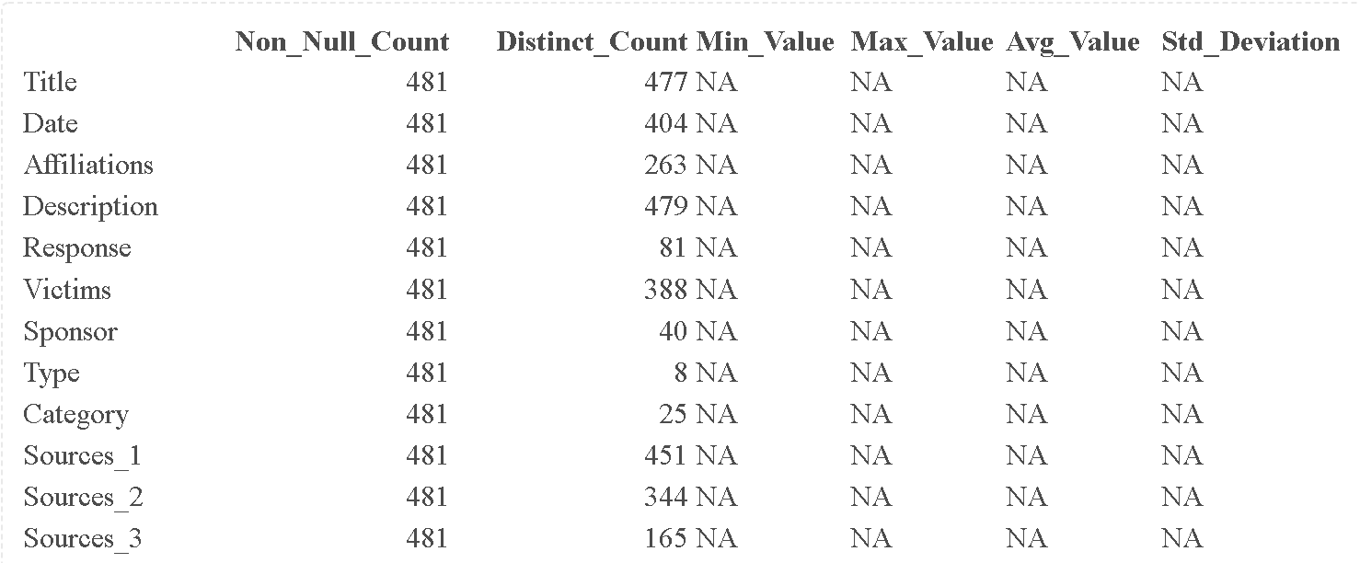

Example:

| Title | Date | Affiliations | Description | Response | Victims | Sponsor | Type | Category | Sources_1 | Sources_2 | Sources_3 |
| --- | --- | --- | --- | --- | --- | --- | --- | --- | --- | --- | --- |
| Attack on Austrian foreign ministry | 2/13/2020 | Turla | The suspected Russian hackers conducted a weeks-long attack on Austriaâ€™s foreign ministry. | Confirmation https://www.theregister.co.uk/2020/02/14/austria_foreign_ministry_hack_turla_group_allegs/ | Austrian Foreign Ministry | Russian Federation | Espionage | Government | https://www.theregister.co.uk/2020/02/14/austria_foreign_ministry_hack_turla_group_allegs/ | https://www.bmeia.gv.at/en/the-ministry/press/announcements/2020/02/cyber-attack-on-the-foreign-ministry-is-over/ | |
| Spear-phishing campaign against unnamed U.S. government agency | 1/23/2020 | Konni Group | The suspected North Korean threat actor Konni Group attempted to trick employees of an unnamed U.S. government agency to install malware on their computers via a spear-phishing campaign. | | Employees of the U.S. government | Korea (Democratic People's Republic of) | Espionage | Government | https://unit42.paloaltonetworks.com/the-fractured-statue-campaign-u-s-government-targeted-in-spear-phishing-attacks/#Attribution | | |
| Australian Signals Directorate | 4/6/2020 |  | Responsible for attacking infrastructure that cyber criminals abroad were using to target Australians during the COVID-19 pandemic. | | | Australia | Data destruction | Private sector | https://www.minister.defence.gov.au/minister/lreynolds/media-releases/offensive-against-covid-19-cyber-criminals | https://www.zdnet.com/article/australia-on-the-cyber-offence-to-bring-down-covid-19-scammers/ | |

The hotel booking demand dataset contains data on hotel bookings, including information on the booking, guest, and stay. The dataset was collected from two distinct hotels. The data was collected from January 2015 to August 2017. The dataset consists of 32 variables and 119,390 observations. The variables include information on the hotel, booking details such as arrival and departure dates, room type and price, and guest information such as demographics and number of occupants.

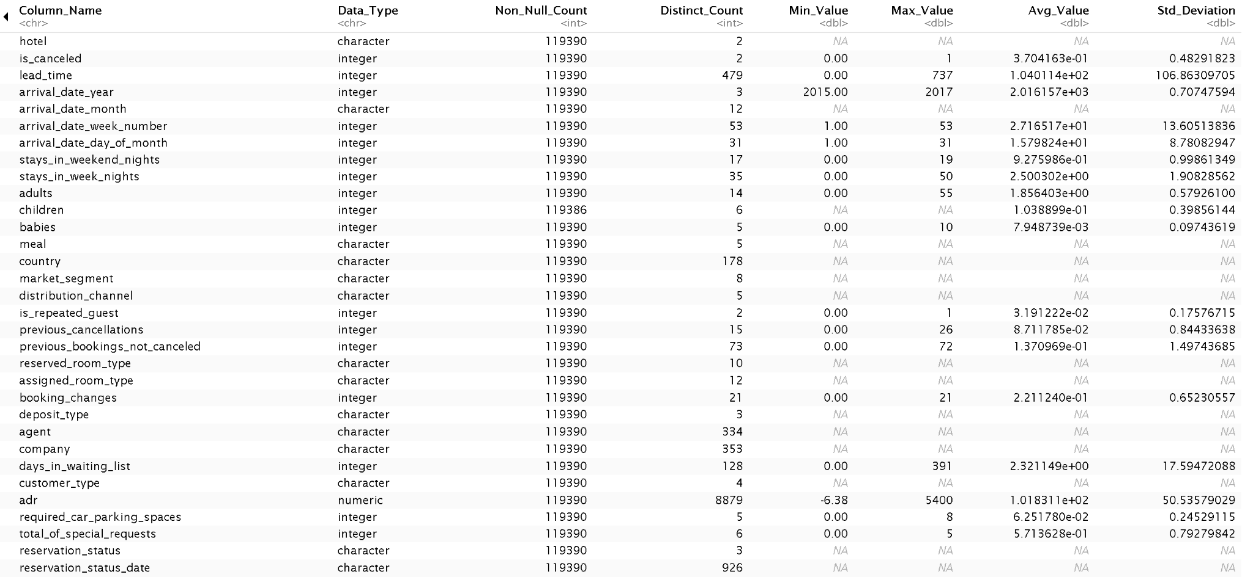

**Example:**



**Most reported Cyber attacks**

The dataset contains information on different types of reported cyber attacks in 2022 and their total number of occurrences. There are 27 types of attacks in the dataset, and the total number of attacks ranges from 20649 to 300,497. The average number of attacks is 26834, and the standard deviation is 56864. There are 27 unique values for the total number of attacks. The dataset has a total of 27 rows and two columns.

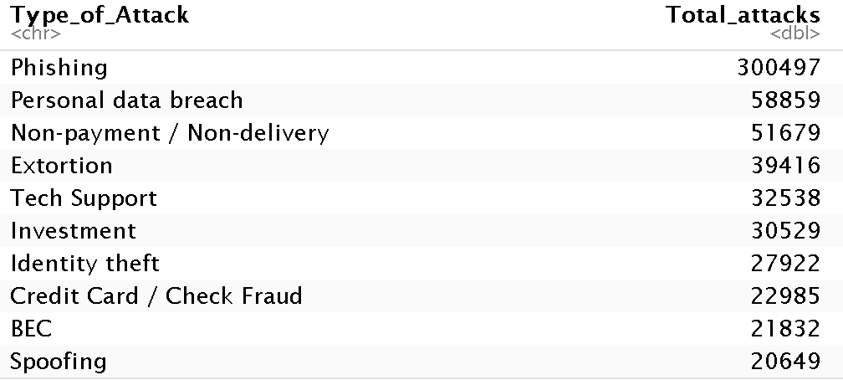



**Cyber compromises**

The data provided in the dataset is about data breaches that occurred between 2005 and 2022. The dataset contains 18 observations. Data breaches vary widely, with an average of 867 and a standard deviation of 503. Records exposed also vary widely, with a min of 157 and a standard deviation of 141 for exposed records. The column on individuals impacted has missing values, making it difficult to draw meaningful conclusions about their impact. Data type was not an included column because it was only date and integers.

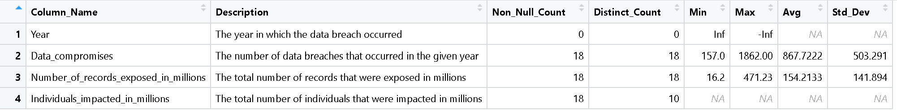

**Example**



**Cost per data breach**

The data provided in the dataset is about the cost of data breaches that occurred between 2006 and 2022. The dataset contains 17 observations. Data cost varies widely, with an average cost of 6.8 mill and standard deviation of 5.09 years. The dollar standard deviation is 1.53.

**2006 to 2022**



**example:**

**Cyber attacks compromised environments**

The table represents the number of cyber attacks in 2019 by industry and IT environment targeted. The IT environments targeted include Corporate/internal network, E-commerce, Cloud, and Point-of-sale (POS). The point of sale standard deviation is 7 while e-commerce is 26 at the highest compromised industry.

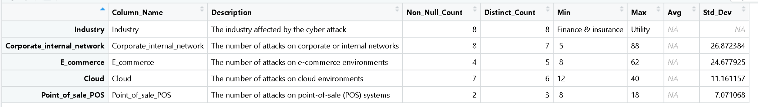

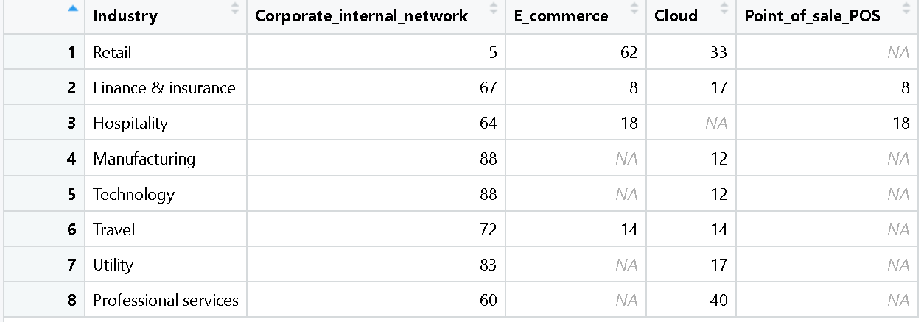

**Example:**



**Part 4: Group Roles and Signatures**

Erika Banfield:

I helped Austin find datasets and worked on Parts 1 and 2 with Austin.

Austin Habecker:

Helped Erika find cyber threat datasets and assisted on Part 1 and 2 with Erika

Shelby Chapa

Took notes for group meeting, Worked on Part 3.

**Milestone 3**

**Part 1 - Observations on Data Patterns**

**Dataset: Data Breaches**

**For the Data Breaches dataset both Bar chart and Word Cloud were chosen. The Bar chart was selected because it best displays the distribution of cyber incidents by year. A pattern that is seen in this visualization is that the graph is distributed and skewed to the left or has a negative skew. With the highest instance around 2020. The word cloud was also chosen because it gave useful insight on the sponsor of many cyber security incidents that occur worldwide. In analyzing the word cloud Many of the cyber attacks occur by China and the Russian Federation. This is relevant to the hospitality industry in that it is important to identify the source of cyber attacks.**

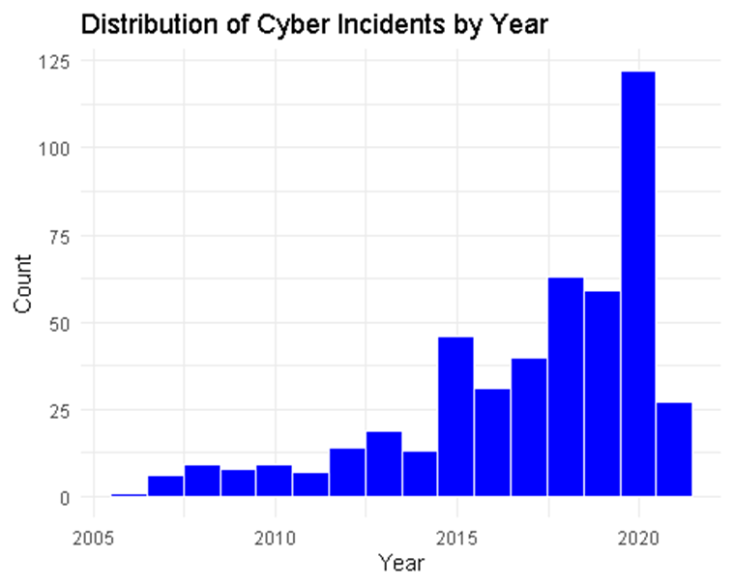

**The dataset contains various cybersecurity incidents that have occurred worldwide, including cyber espionage, hacktivism, cybercrime, and cyber warfare. The dataset covers incidents reported from 2005 to 2020.**

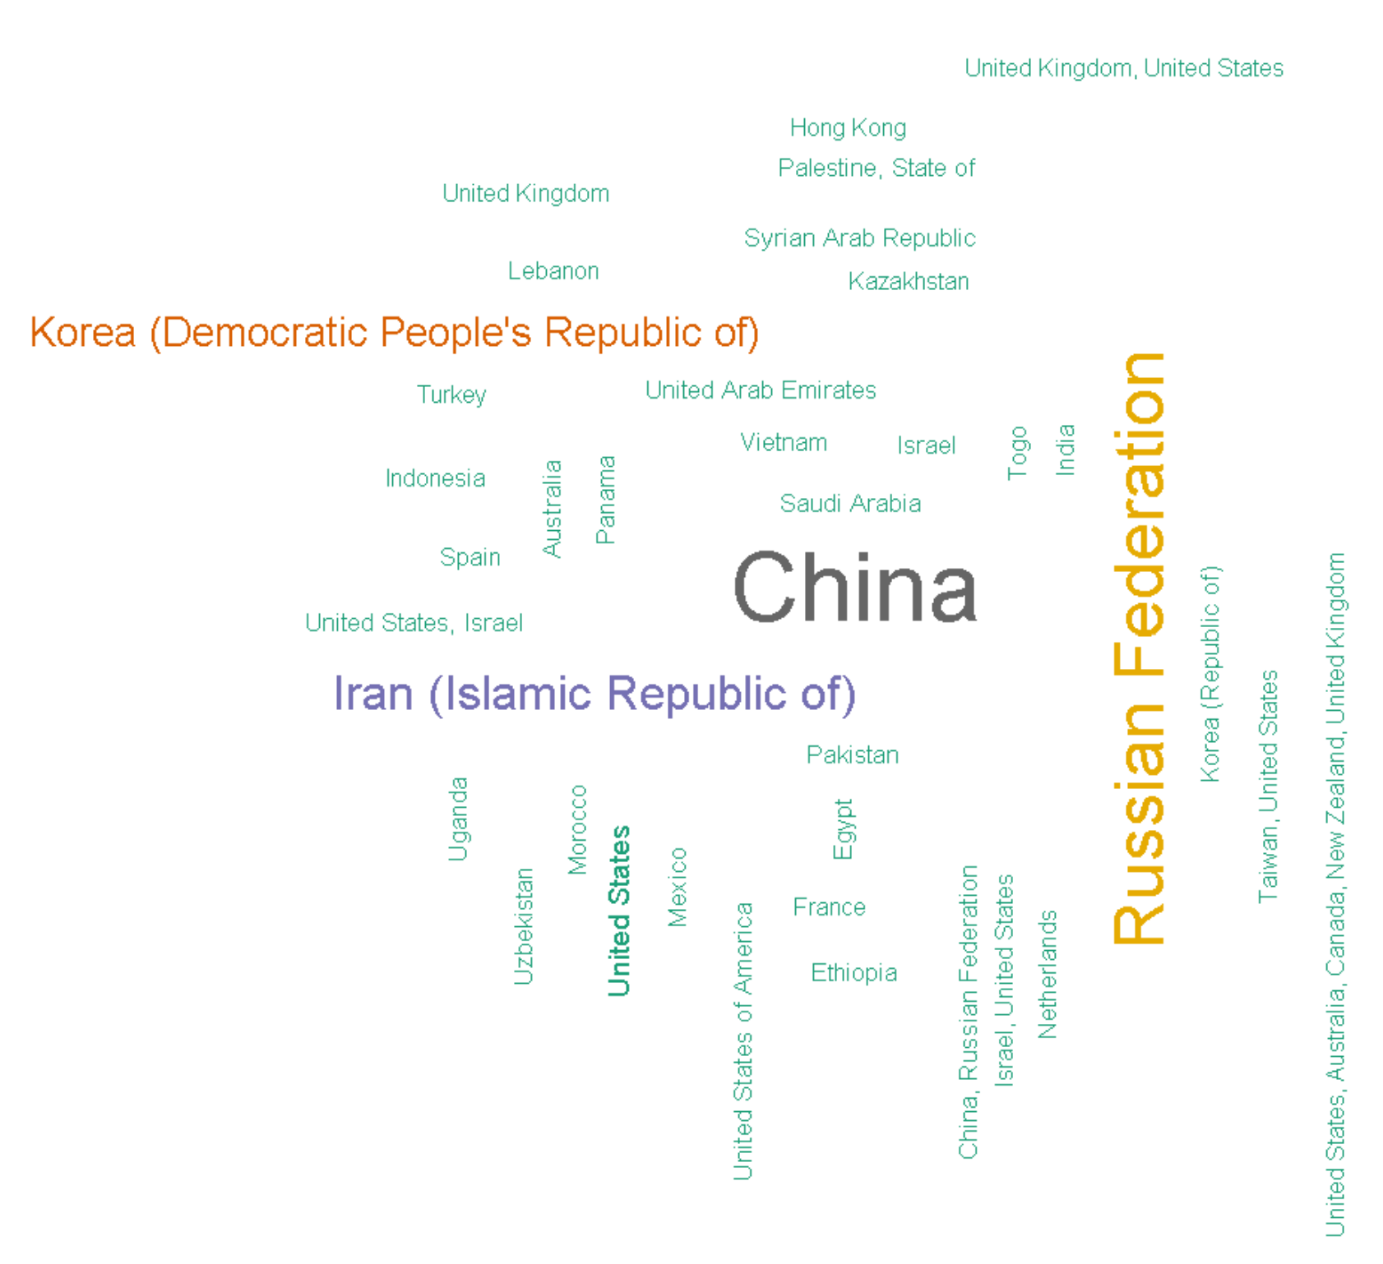

**Dataset: Hotel booking demand**

**For the Hotel booking demand dataset two Bar charts were chosen. The Bar chart was selected because it best displays the distribution of City vs Resort hotels. This is significant due to the fact that it identifies that most attacks to the hospitality industry are to city hotels because of the higher rate of bookings rather than resorts. The highest booked months are July and August. A distribution line was added to display the normal distribution. This is relevant due to the fact that more cyber attacks in the hospitality industry are likely to occur in the higher booked months.**

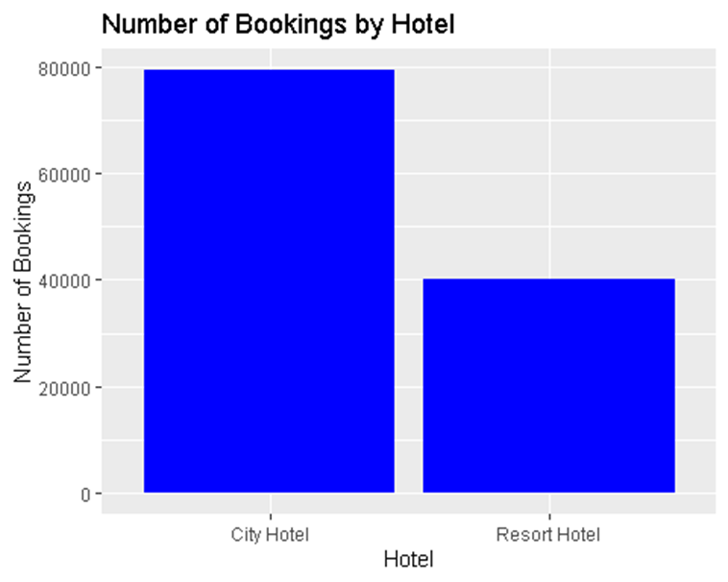

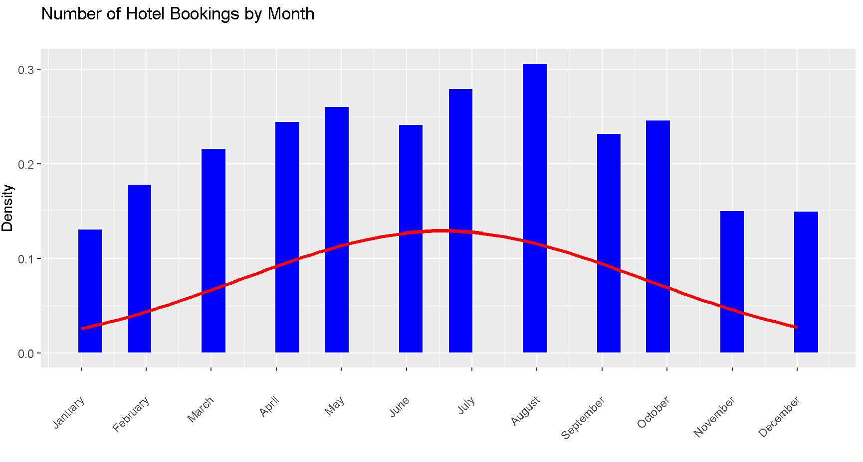

Dataset: Most reported types of cyber crime worldwide 2022, by number of individuals affected

**For the** Most reported types of cyber crime worldwide **dataset a Bar chart and word cloud were chosen. The Bar chart was selected because it best displays the distribution of Attacks and Fraud type. It is apparent how Phishing is the most prominent attacking method for individuals. In the bar chart. A word cloud was also used to identify other threats visually. The barchart values look very low compared to the word cloud, however the word cloud identifies other threats effectively. It still has phishing as the biggest threat at a max value of 300497 and also highlights non-payment/delivery and personal data breaches. Which is important to identify because though phishing is common the hospitality industry can be subjected to other types of attacks as well. It is good to be vigilant of many threats.**

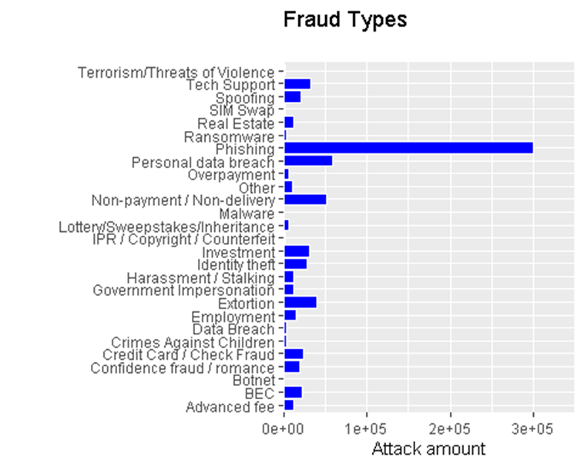

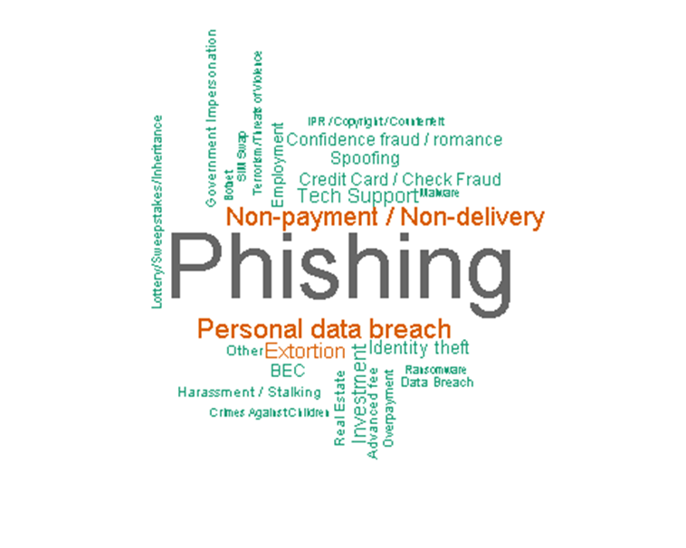

Dataset: Annual number of data compromises and individuals impacted in the United States from 2005 to 2022

**For the** Annual number of data compromises and individuals impacted in the U.S **dataset two Bar charts were chosen. The Bar chart was selected because it best displays the distribution of data compromises and records exposed by the year. Both charts display large increases as time progresses indicating more data records and data compromises are occurring as time passes. However it is worth identifying that records exposed have decreased as 2022 approaches. This is useful data to the hospitality industry in that they can provide resources to increase their data security. The increased compromises are a clear indicator that data security should be a priority to business.**

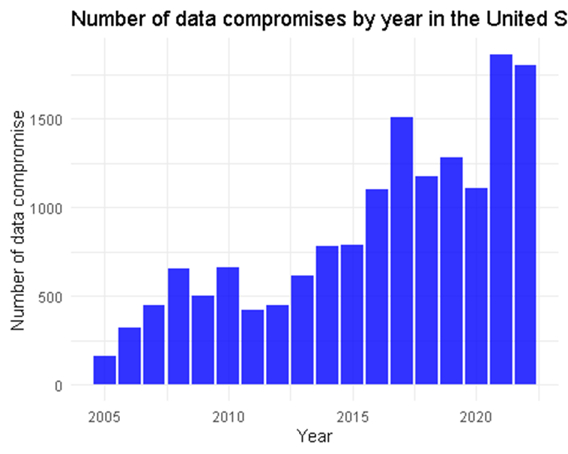

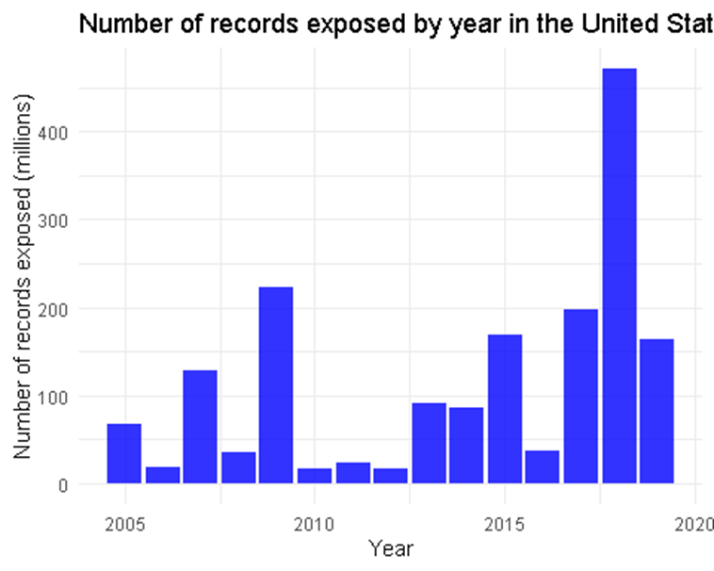

Dataset: Average cost of a data breach in the United States from 2006 to 2022

**For the** Average cost of a data breach in the United States **dataset a scatter plot and line graph was chosen. The scatter plot was selected to see if there is a trend or pattern in the average cost of a data breach. It appears to trend upwards starting from 2012-13 and on. A line graph was then made to try to confirm this hypothesis. It appears as const increases as time progresses indicating that data breaches are becoming more expensive as time progresses with an average cost of 6.8 mill. This is useful data to the hospitality industry in the context of CTI, it is less costly to have good data security and mitigate losses.**

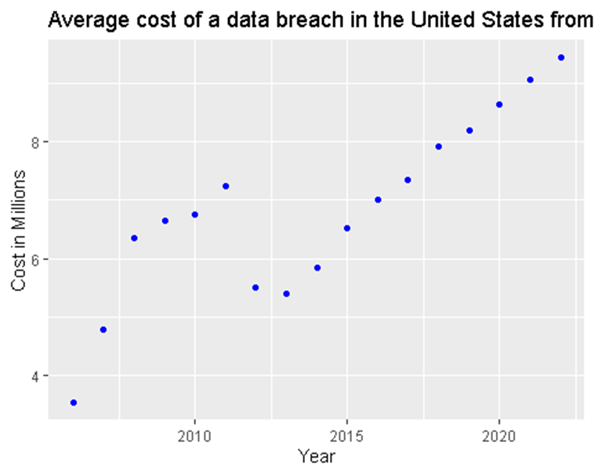

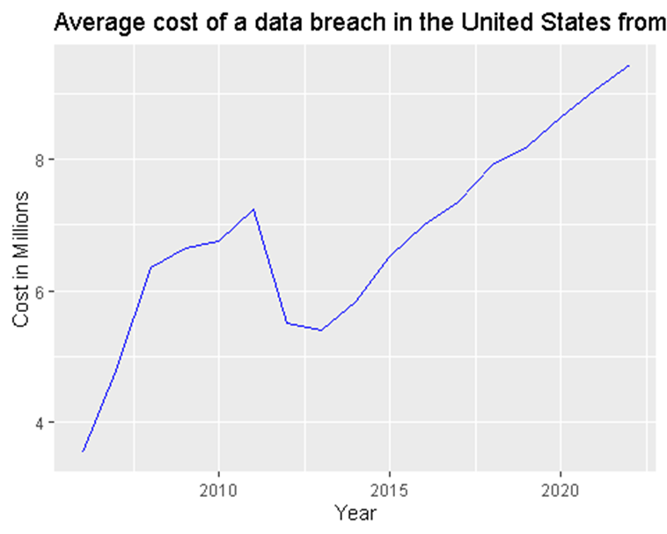

Dataset: IT environments targeted by cyber attacks worldwide in 2019, by industry

**For the**  IT environments targeted by cyber attacks worldwide dataset, **a stacked bar graph and pie chart was chosen. The stacked bar graph was selected to visualize the most impacted industries that are targeted by cyber attacks. The pie chart was chosen to identify the percentage of IT environments that are attacked for the hospitality industry. The highest target industry overall is the corporate internal networks at a max of 88 and the lowest is POS. For the hospitality industry pie chart, POS and Ecommerce were lower than the corporate internal network as well. With Ecommerce and POS having equal parts of the pie chart. This is useful data to the hospitality industry in the context of CTI, because it identifies the area of protection that should take priority. Corporate internal networks should be the most secure because they are targeted by cyber attacks more frequently.**

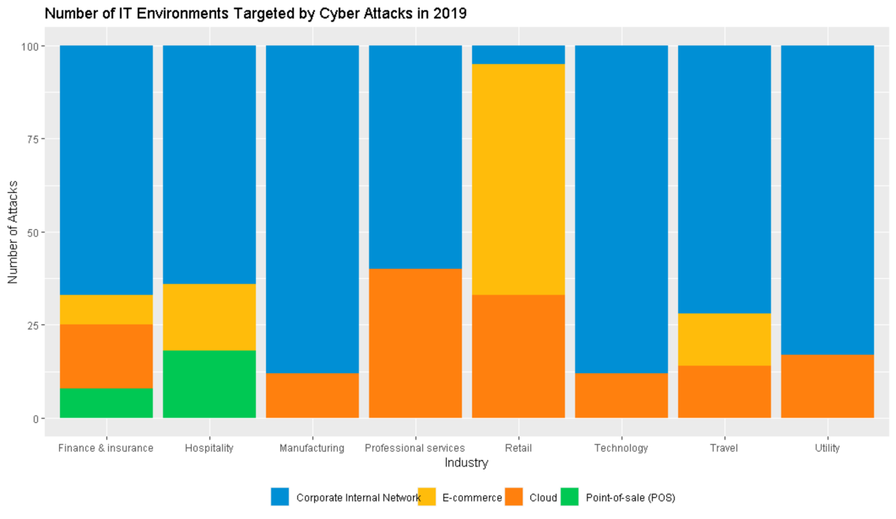

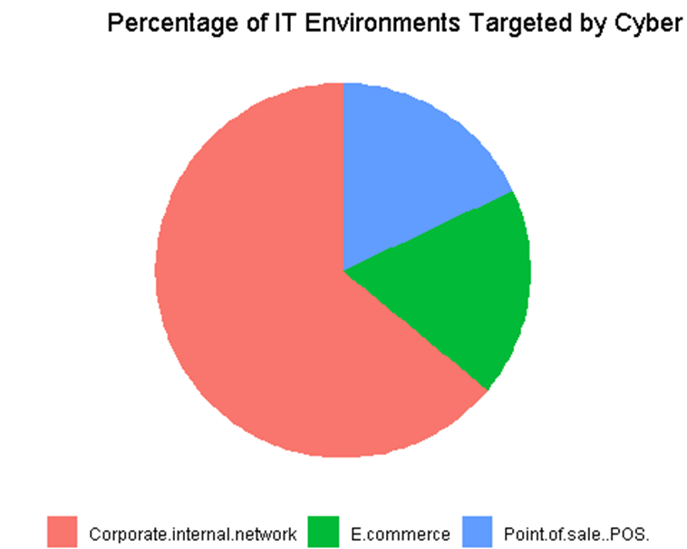

**Part 2 and 3: Option 3 more visualizations**

**IT environments targeted by cyber attacks worldwide in 2019, by industry**

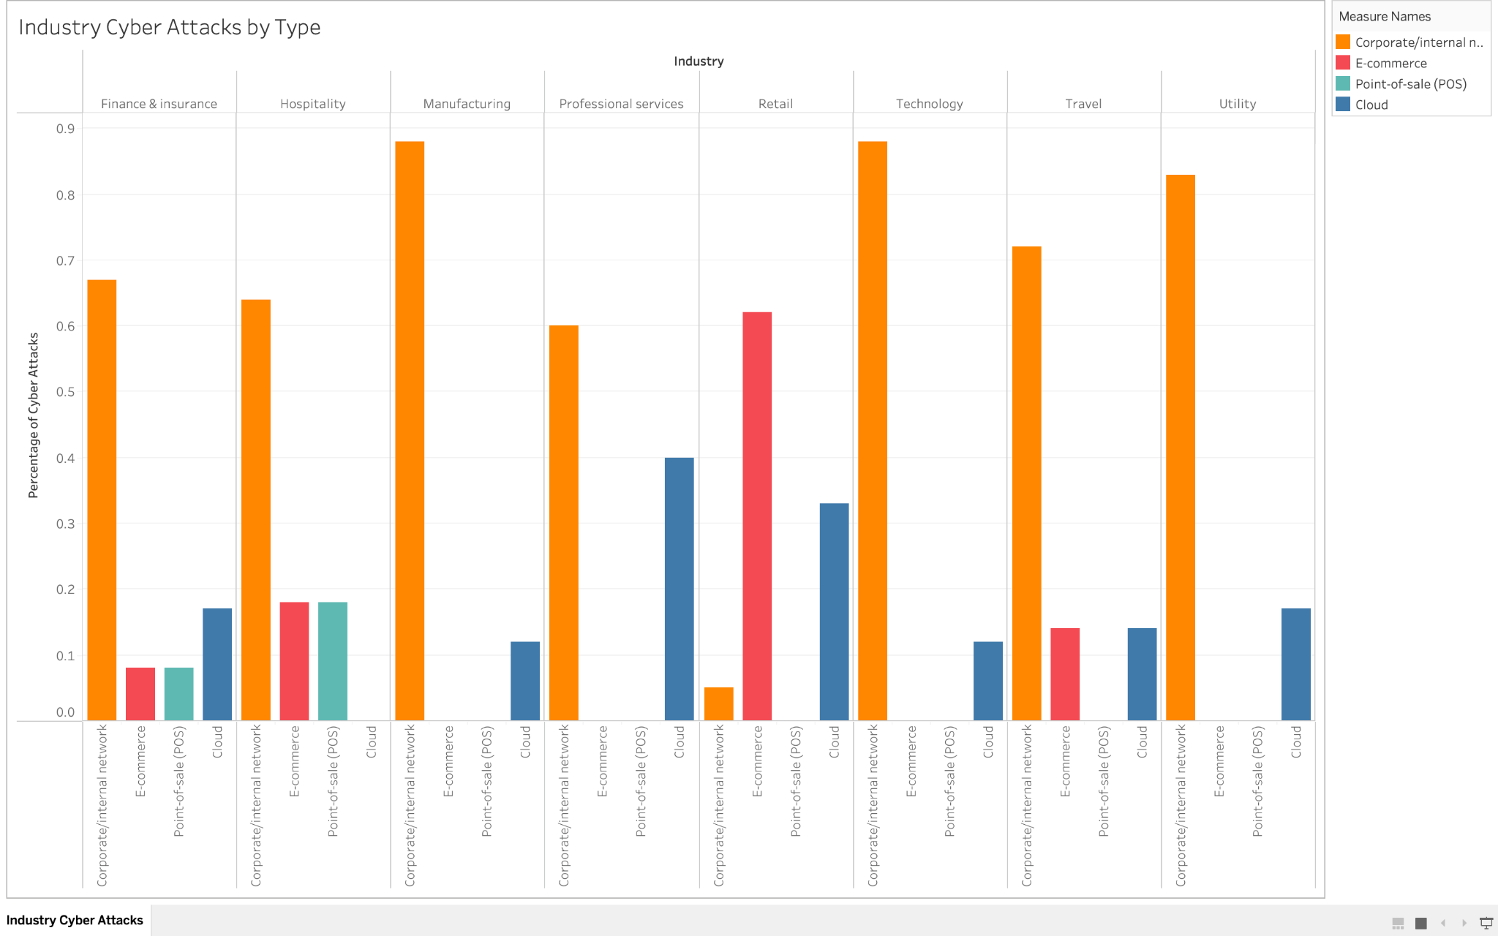

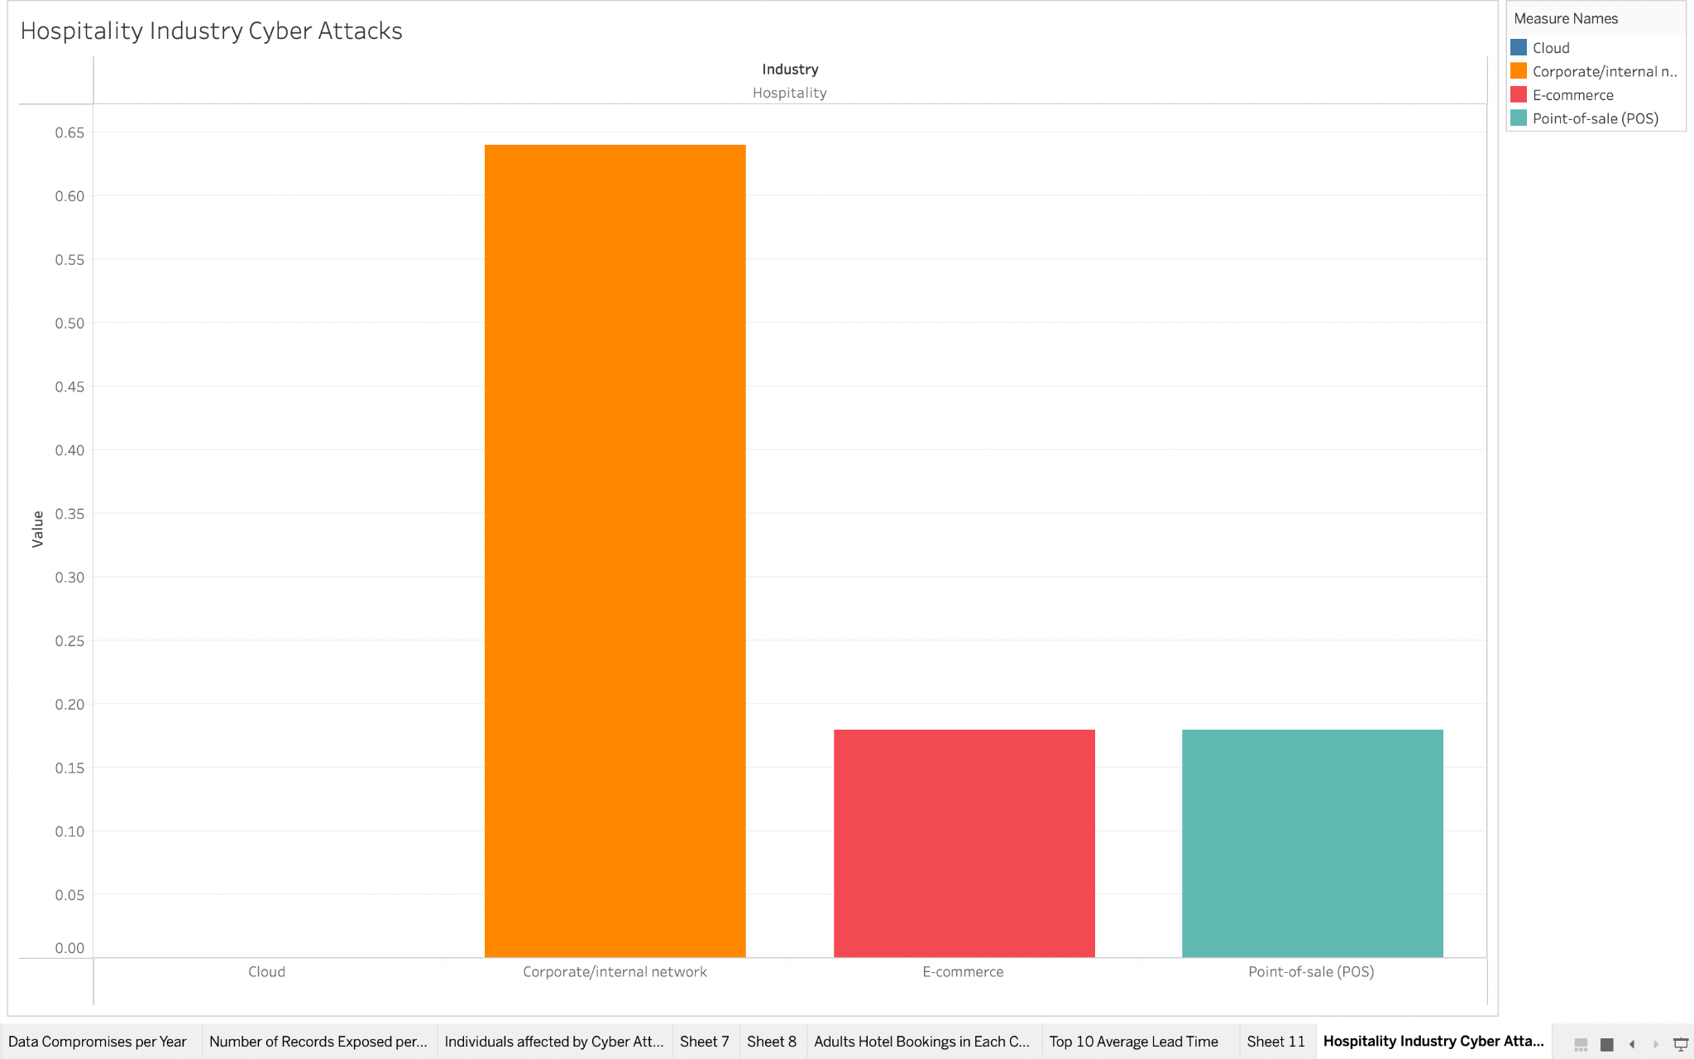

These charts show how different industries primarily experience Cyber Attacks. The values are percentages of the total number of attacks by industry. The four categories are Corporate/Internal Networks, E-Commerce, Point-of-Sale (POS) and the Cloud. Looking closely at the hospitality industry for the purposes of our company, we can see that the majority of cyber attacks are experienced through corporate/internal networks. Specifically, 64% of cyber attacks experienced by the hospitality industry in 2019. The other 36% are split evenly between E-Commerce (18%) and Point-of-Sale (18%). This shows our company how much of a target the hospitality industry is when it comes to cyber crime and where weak points tend to be. This will help us understand where we need to focus our time and money in order to protect our critical assets.

**Most reported types of cyber crime worldwide 2022, by number of individuals affected**

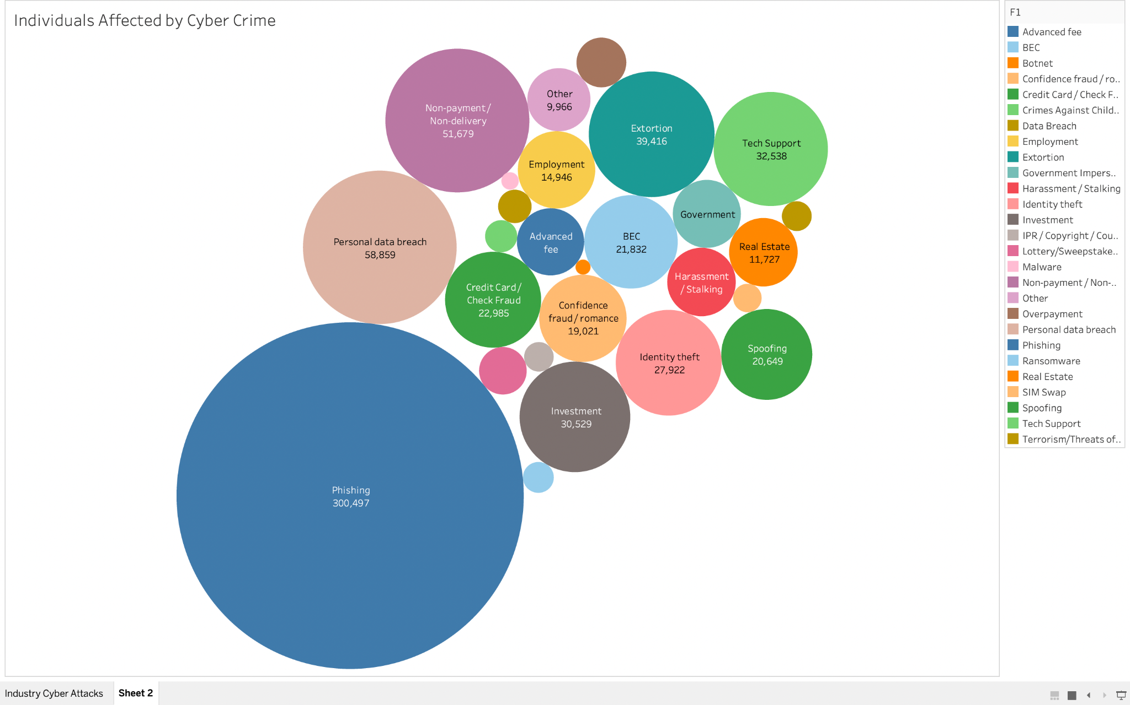

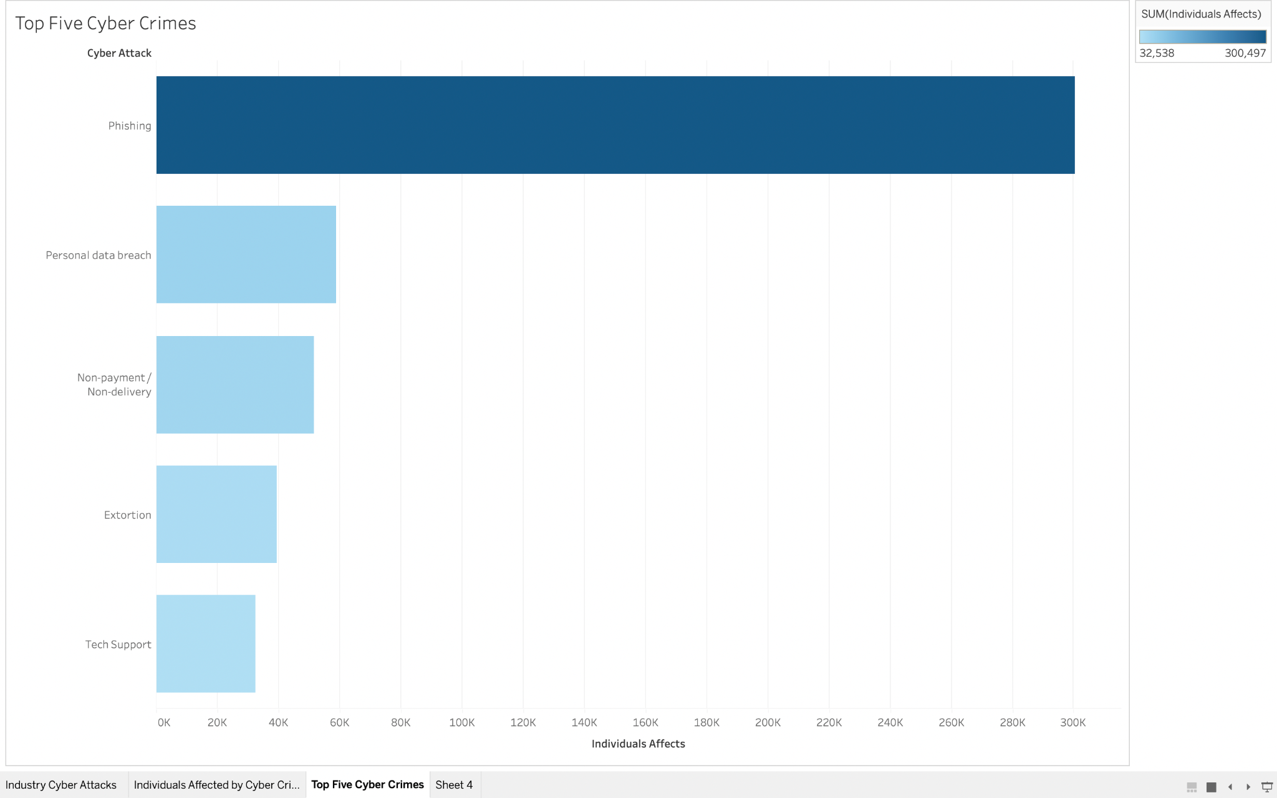

These charts show the impact of different types of Cyber Crimes by showing the number of individuals affected in 2022. As we can see in the visualizations above, the top five most impactful cyber crimes were, phishing, personal data breach, non-payment/non-delivery, extortion and tech support. Phishing is a prevalent tactic used by cyber criminals to infiltrate many businesses in the industry. We recommend that our company invest resources in training for employees to identify suspicious communications.

**Annual number of data compromises and individuals impacted in the United States from 2005 to 2022**

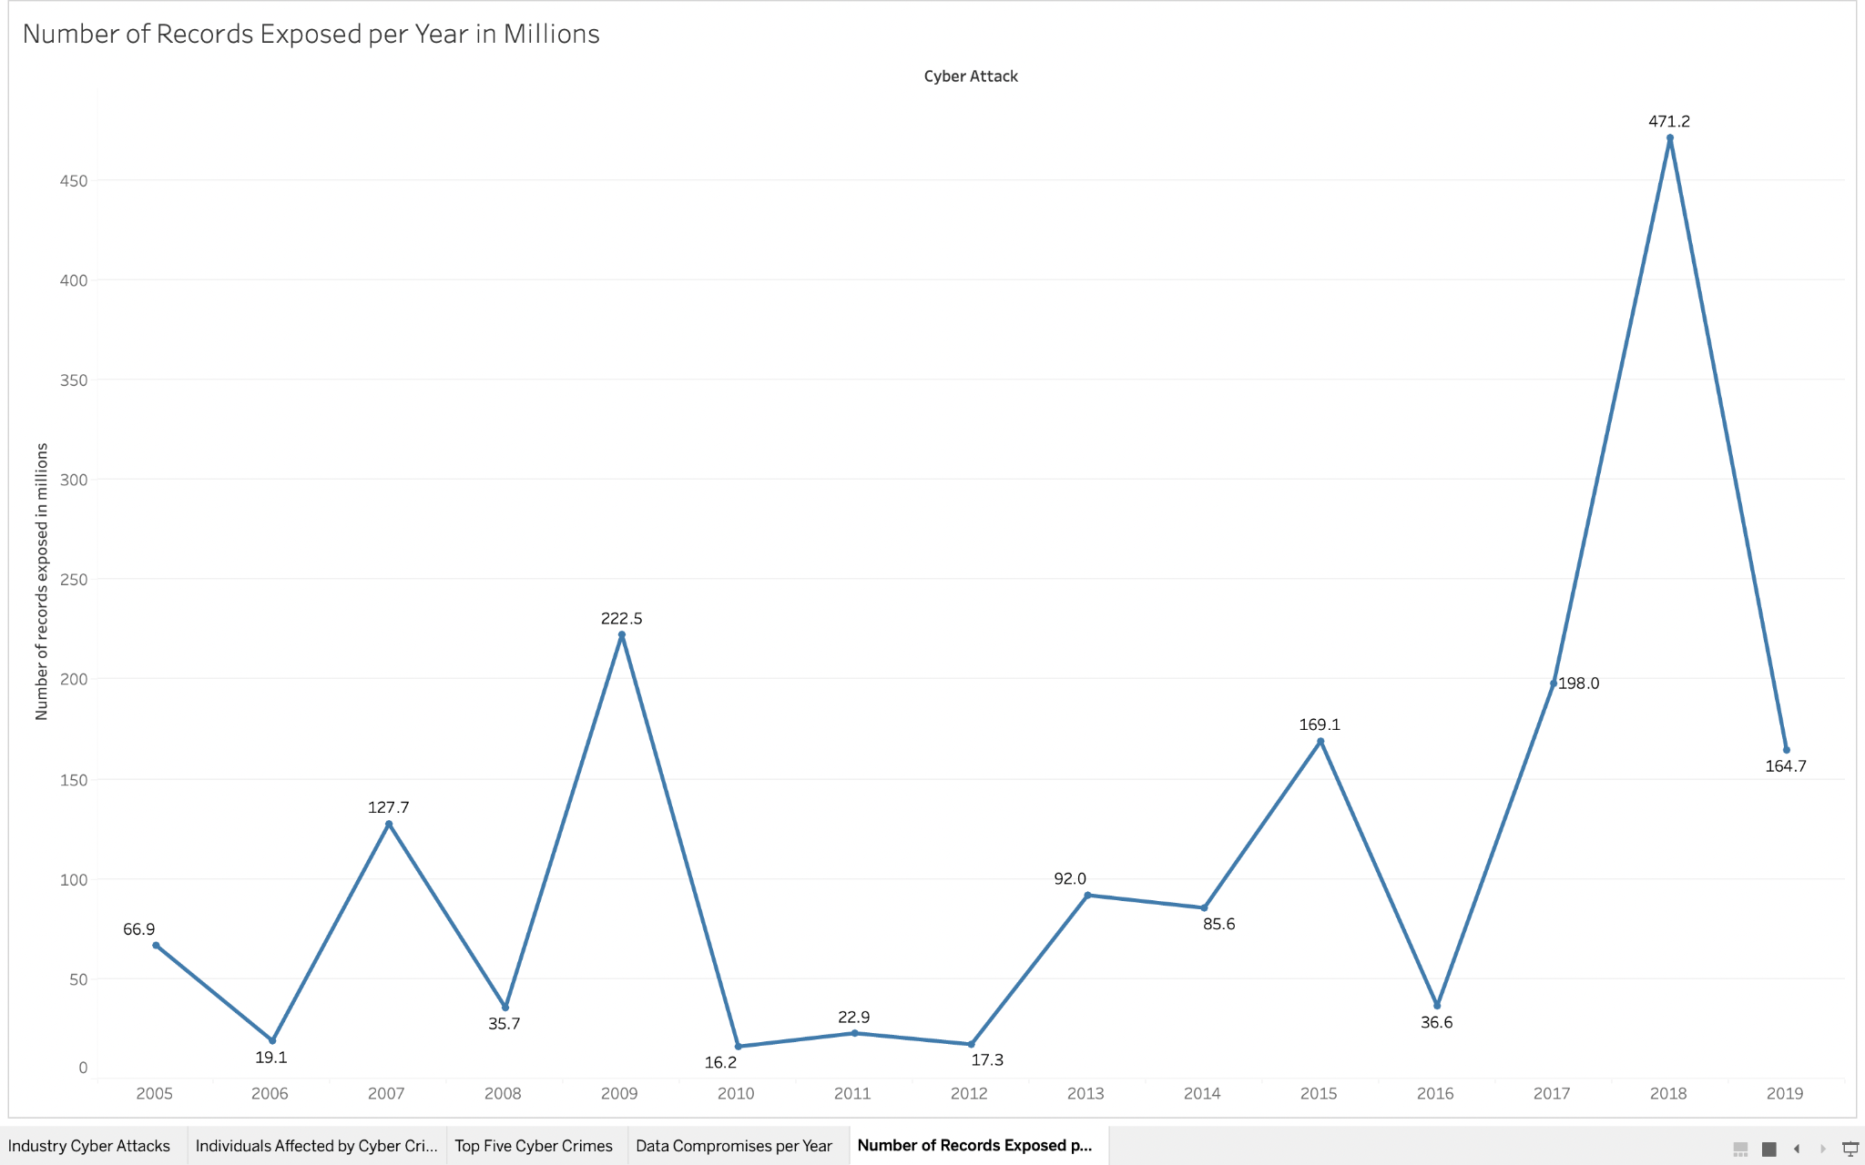

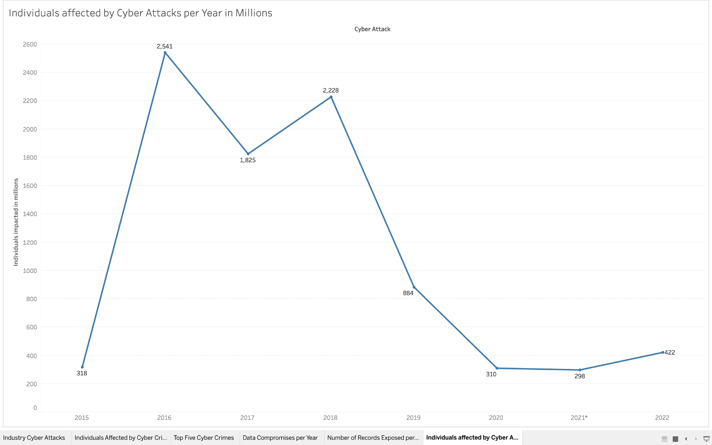

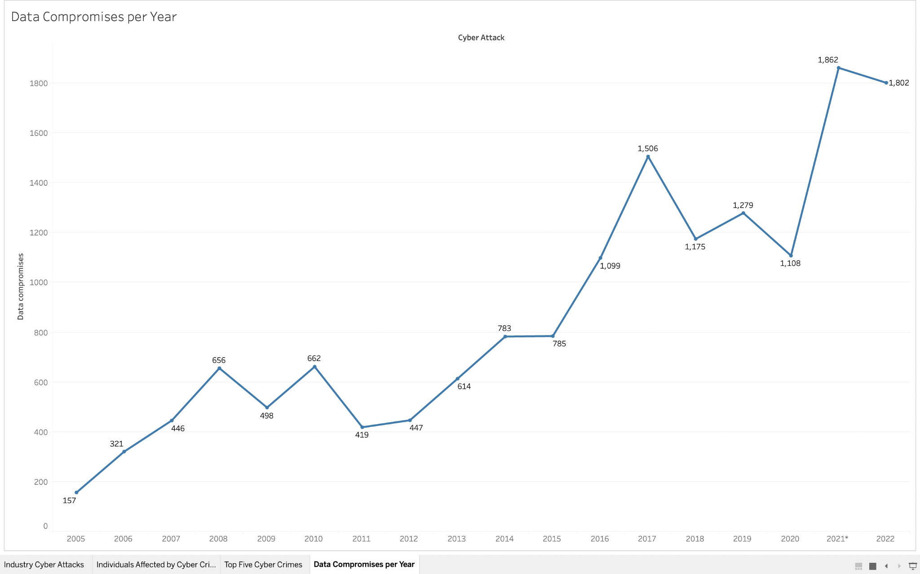

The visualizations above show first, the number of records exposed in millions due to data breaches each year, second, the number in millions of individuals affected by data breaches each year, and lastly, the number of data compromises each year. We can see from these that over the years the amount of data compromises has steadily increased, with a large shoot up in 2020. Looking at the second graph, we can see that even though the number of data breaches has increased, the amount of people affected by them is significantly less than in 2015-2018. This has been possible in part due to the increased amount of cyber defense. Even though attacks continue to increase, as defense improves, individuals are more protected. This is another reason why it is important for our company to invest resources in data protection.

**Average cost of a data breach in the United States from 2006 to 2022**

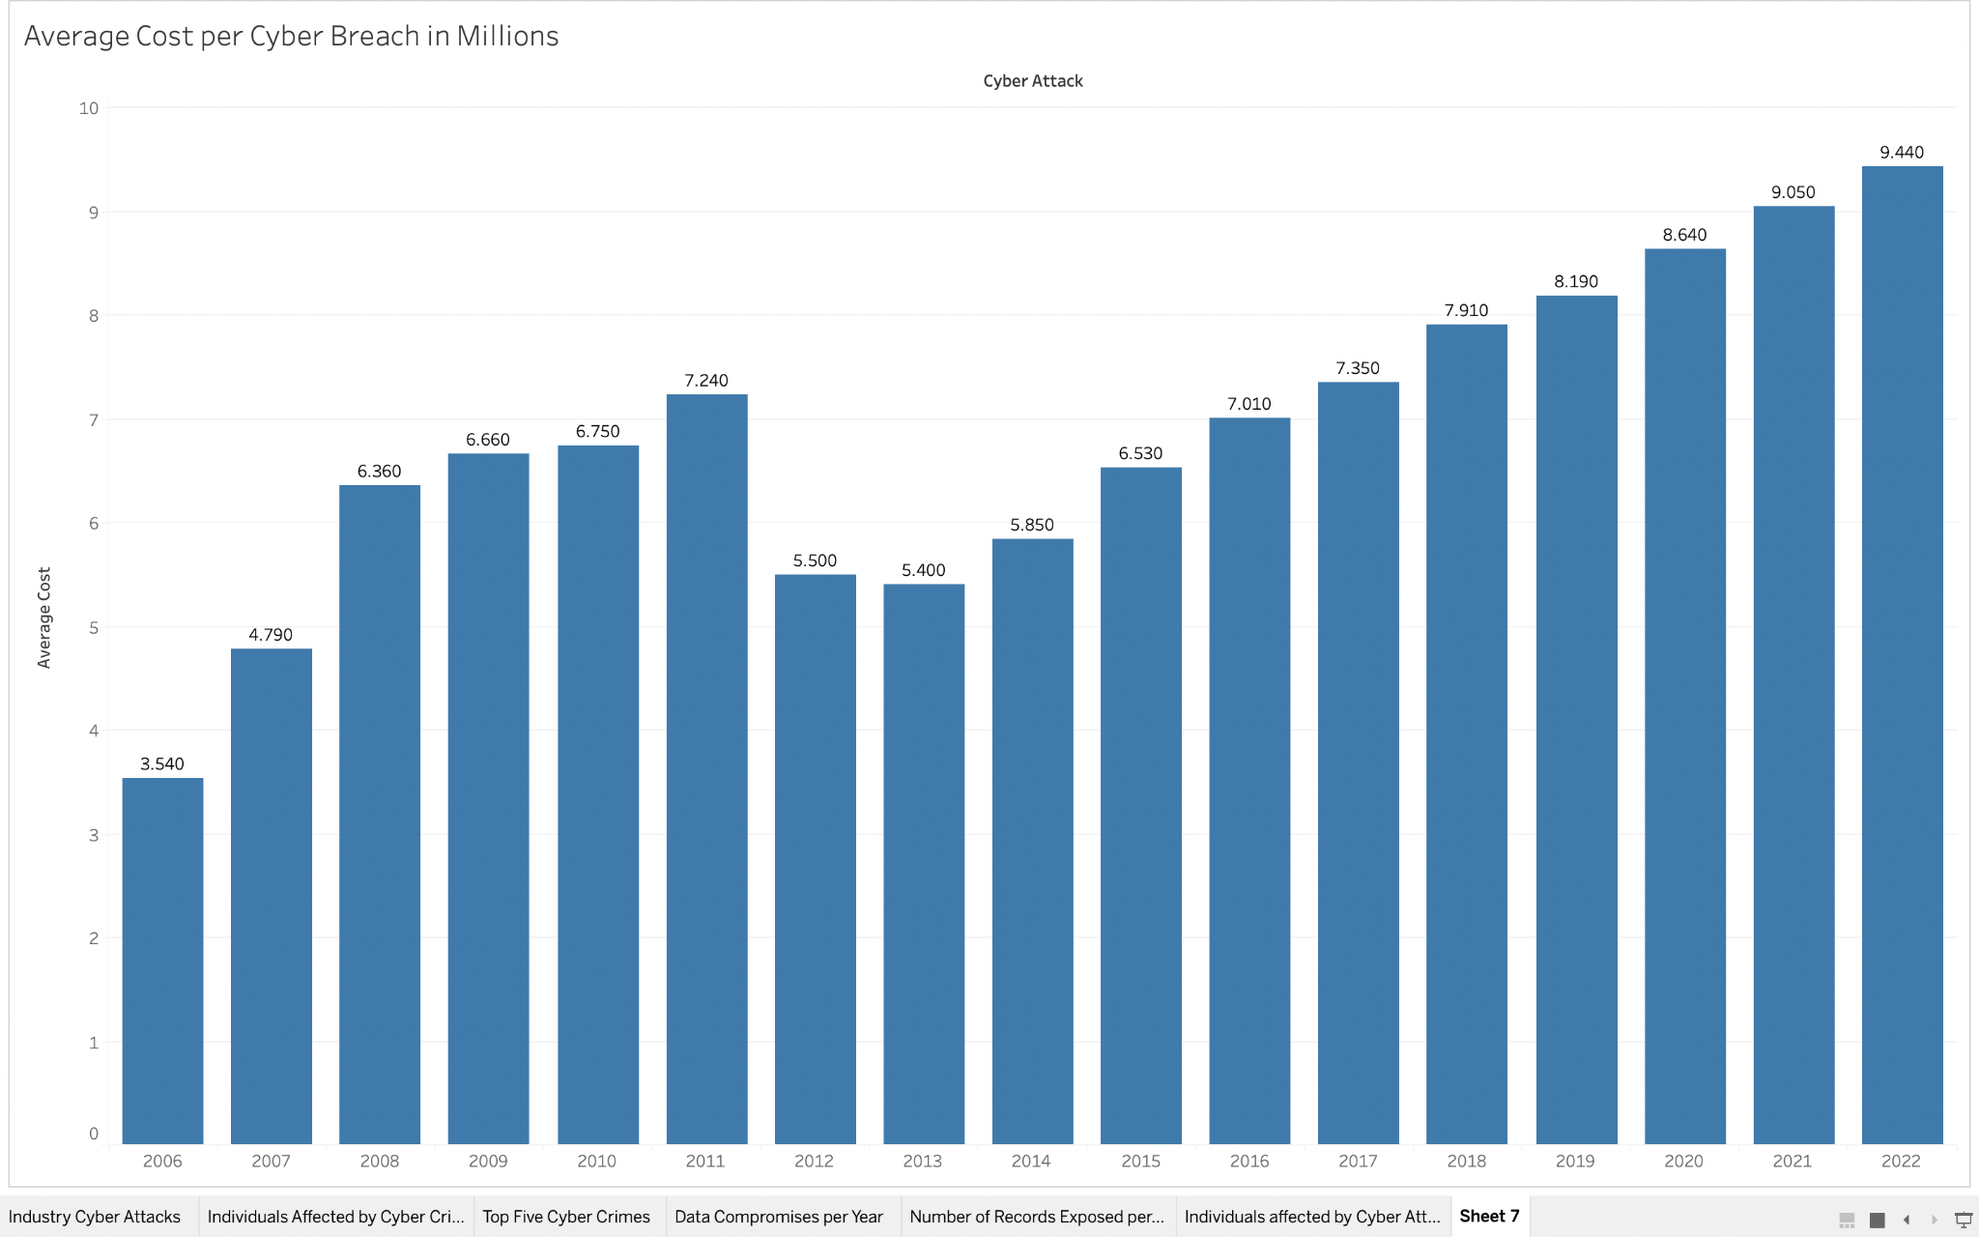

This graph shows the average cost in millions per cyber breach in the United States over the years. As we can see this is another trend that is on the rise, with the average cost in 2022 being $9.44 million. As we saw before, the number of cyber attacks is also rising. This is important for our company to recognize that if we do not make the investment to protect against data breaches they will likely end up costing our company.

**Hotel Booking Demand**

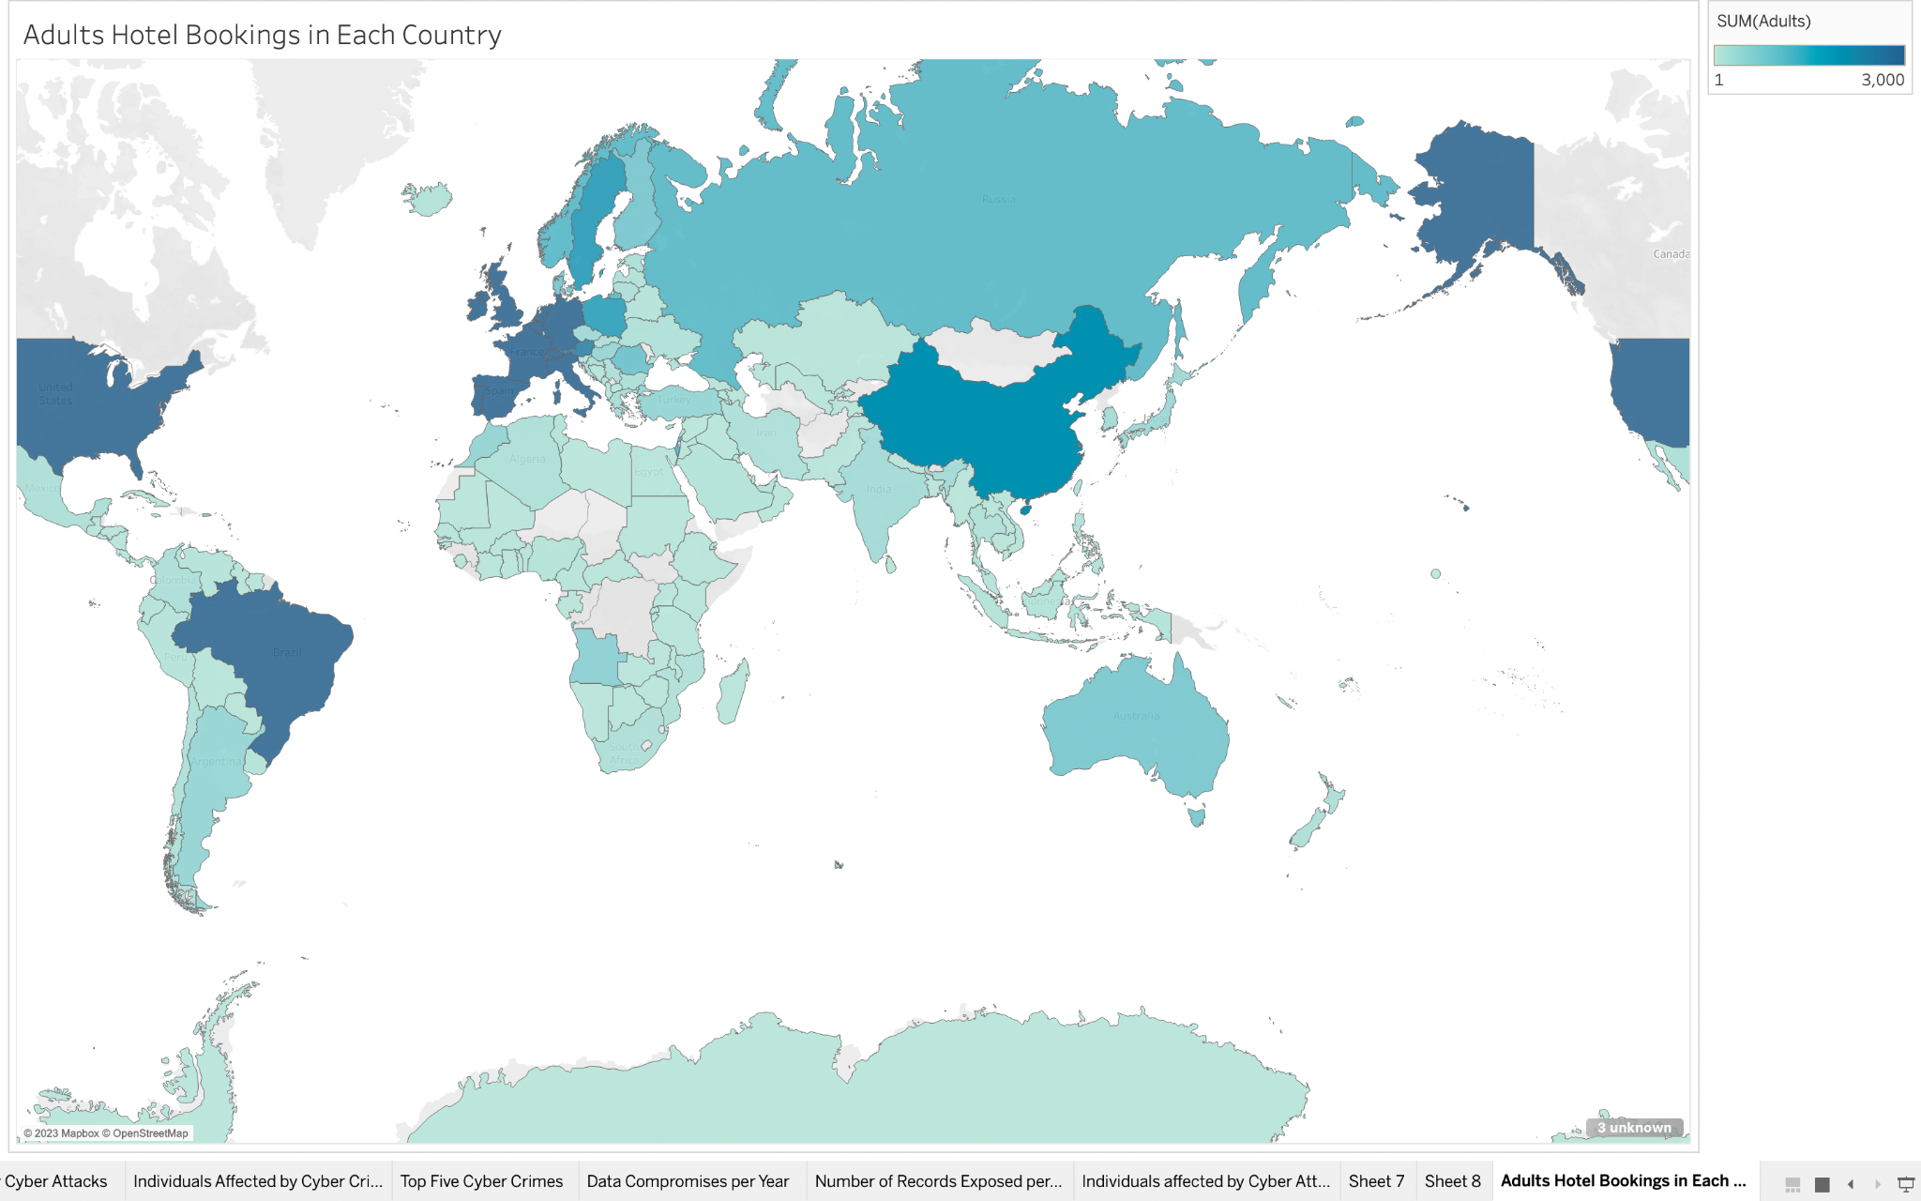

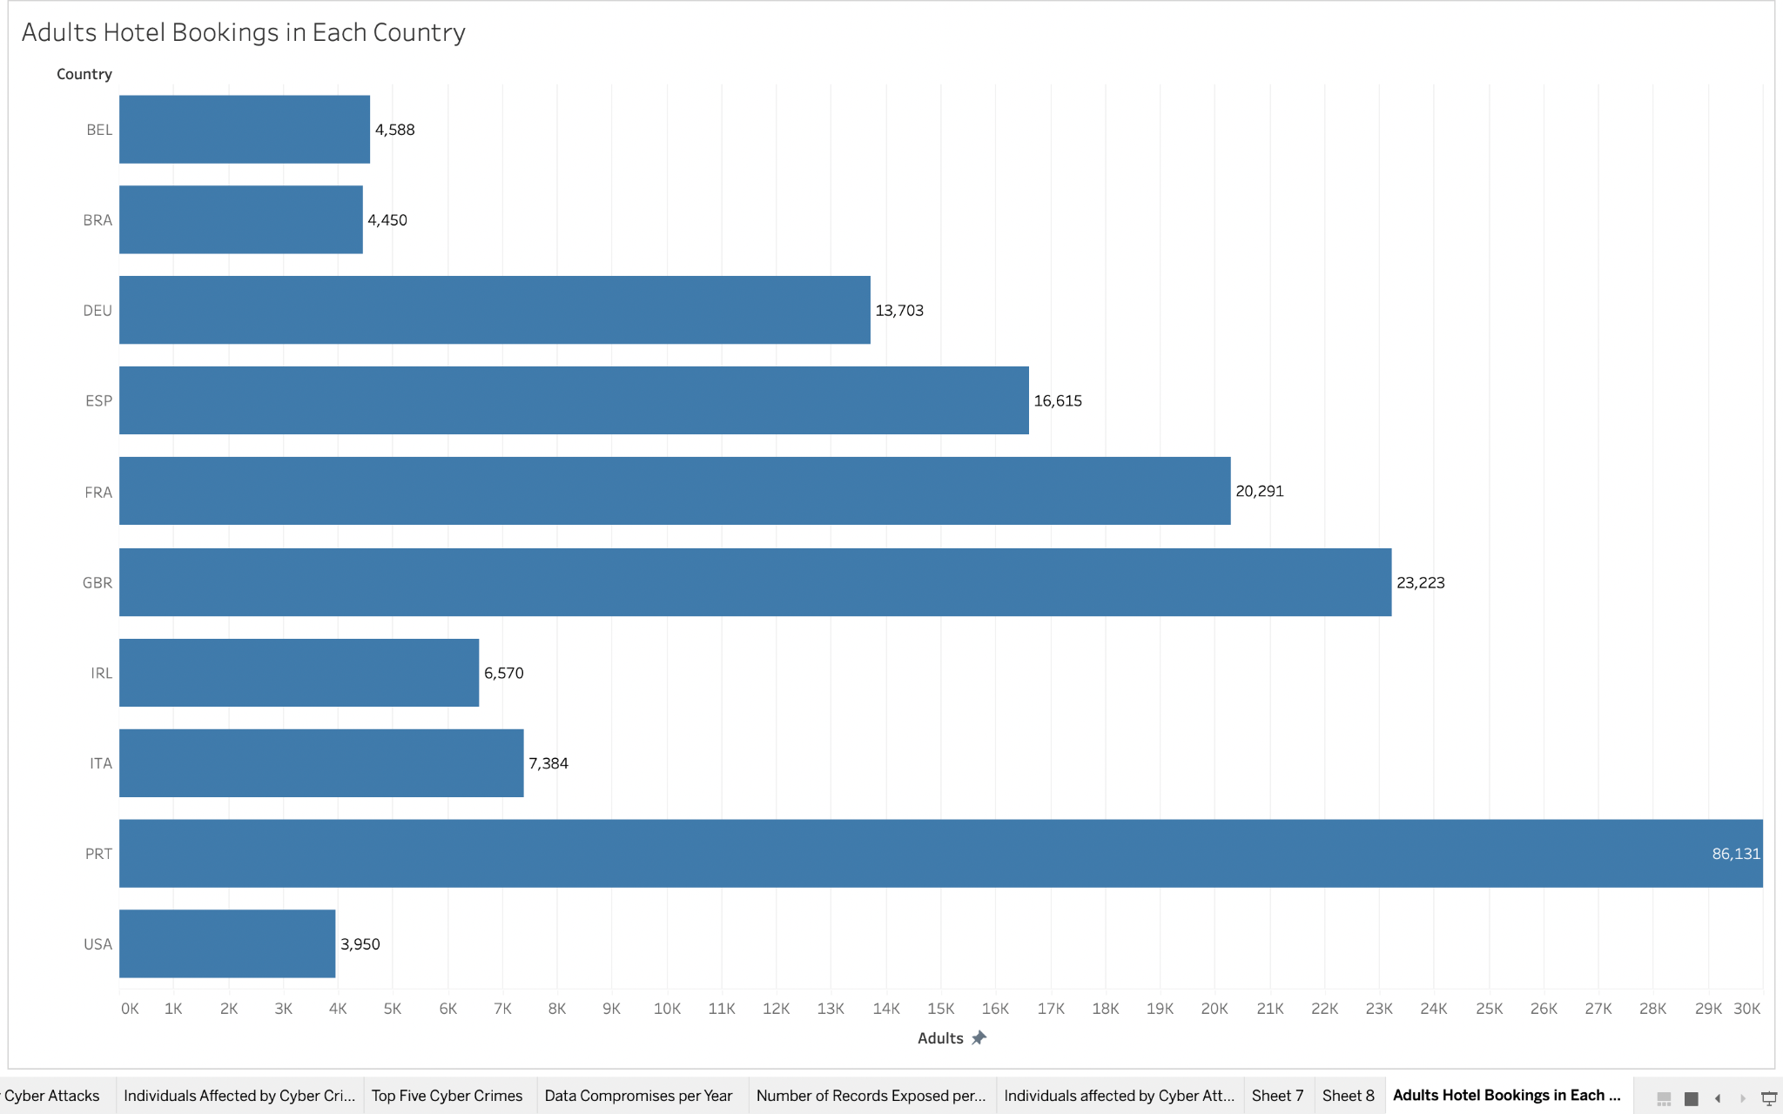

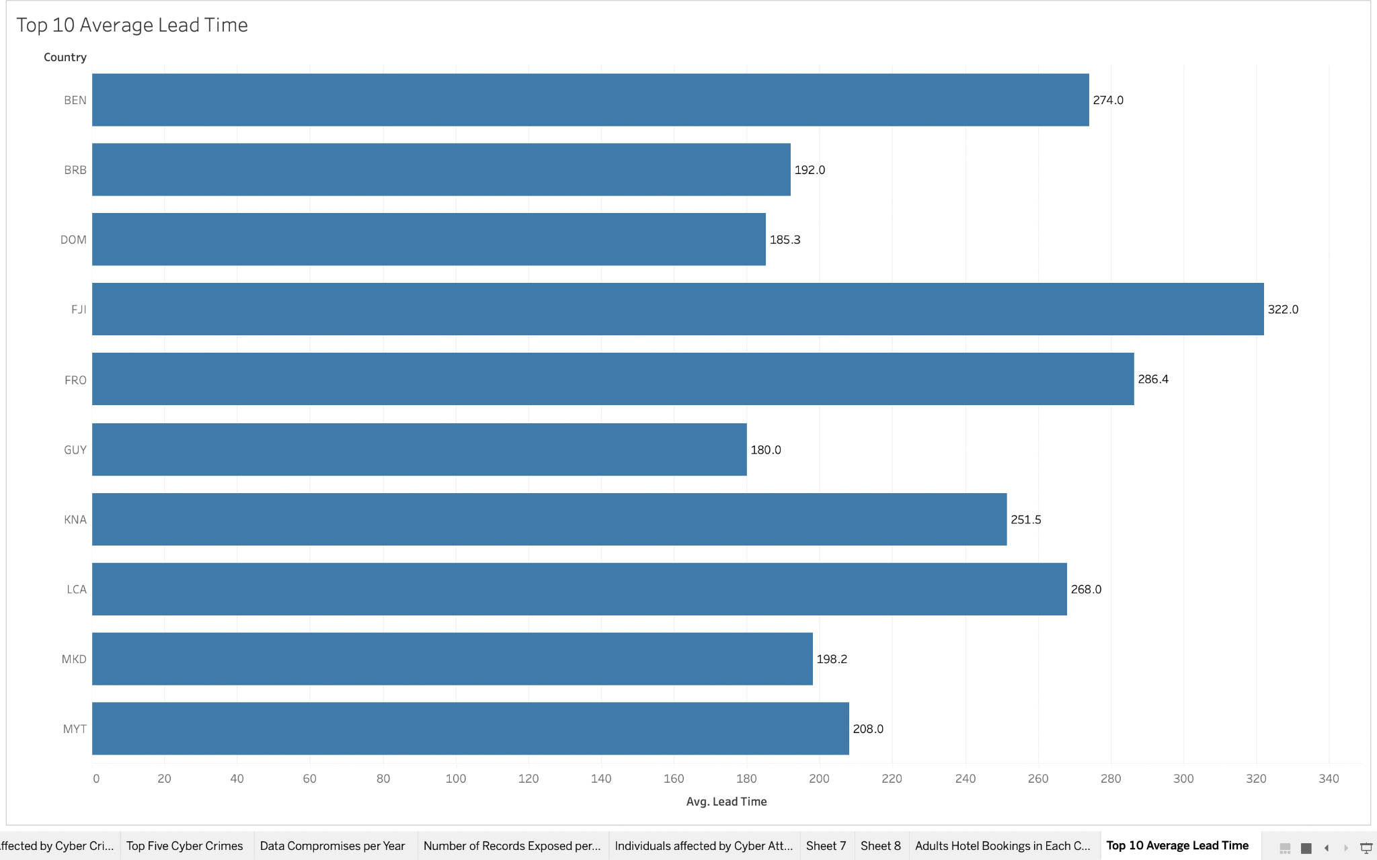

The visualizations above are based specifically on the hotel industry. The top two show the amount of adults who book in different countries around the world. We chose to analyze this because all of their data is now stored in the company or third party’s system and is therefore a possible target and our responsibility to protect. The third visualization shows the top 10 countries with the longest average lead time. This is the amount of time between a guest booking and their stay with the hotel. This is another representation of data that is now our responsibility. This not only includes personal guest information and financial data, but also where they will be when. As stated it is our company's responsibility to our guests to protect their data. If not, we risk losing customer trust and facing lawsuits.

**Data Breaches**

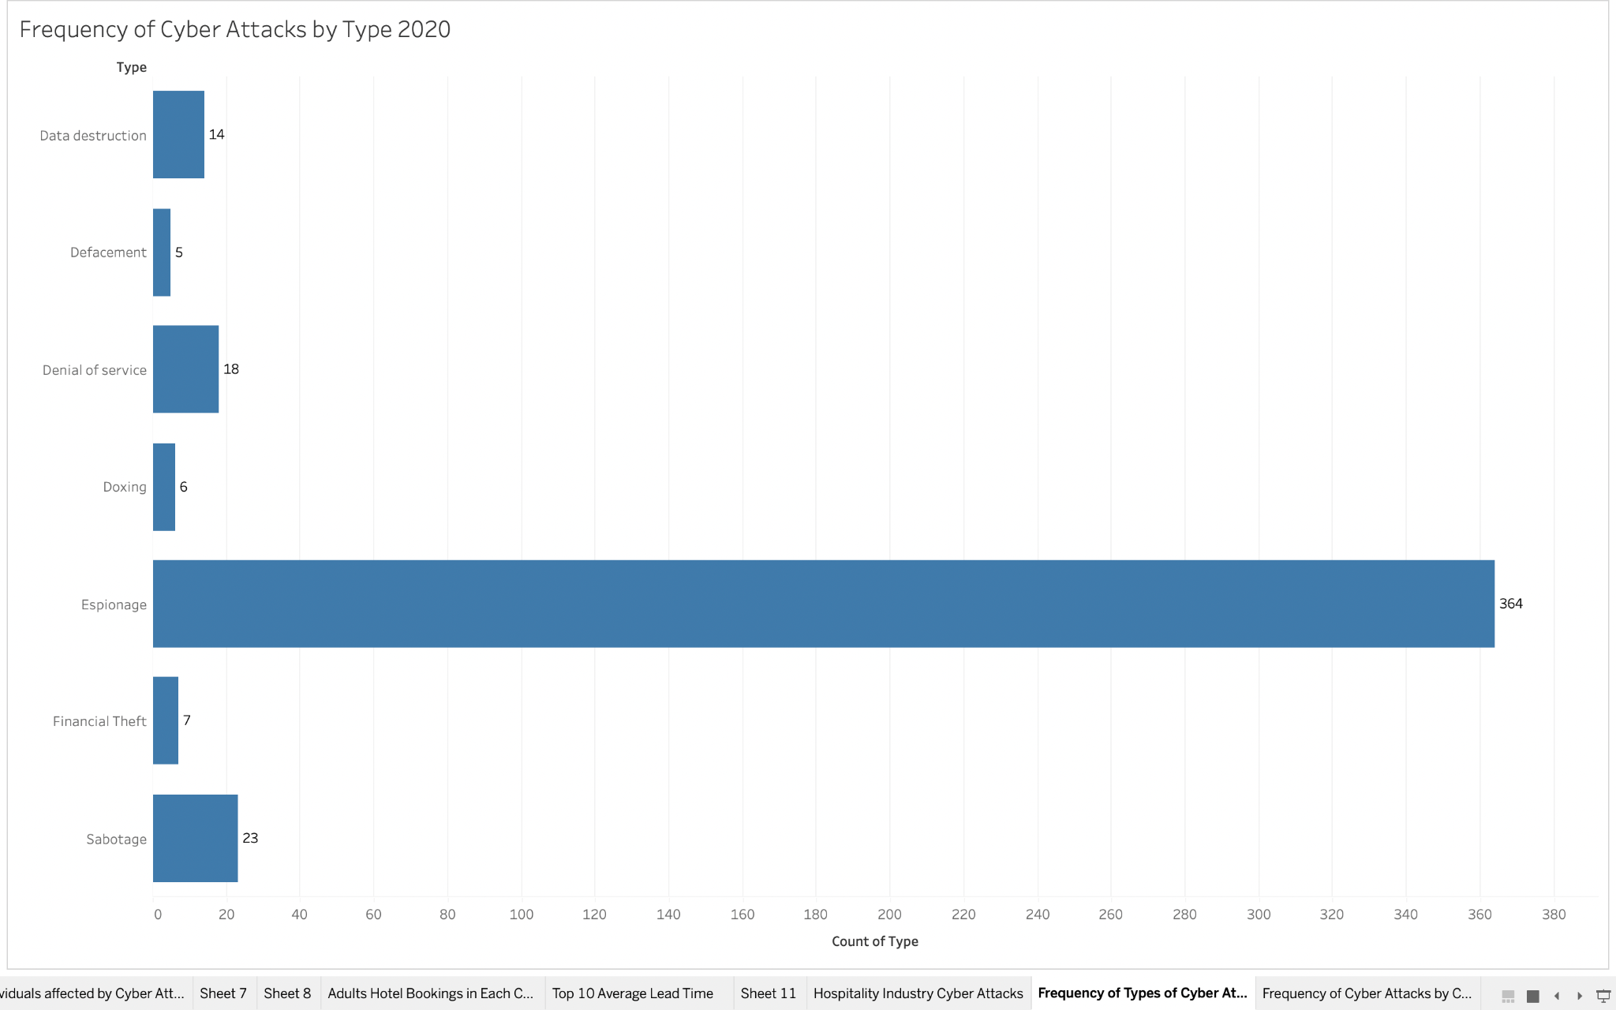

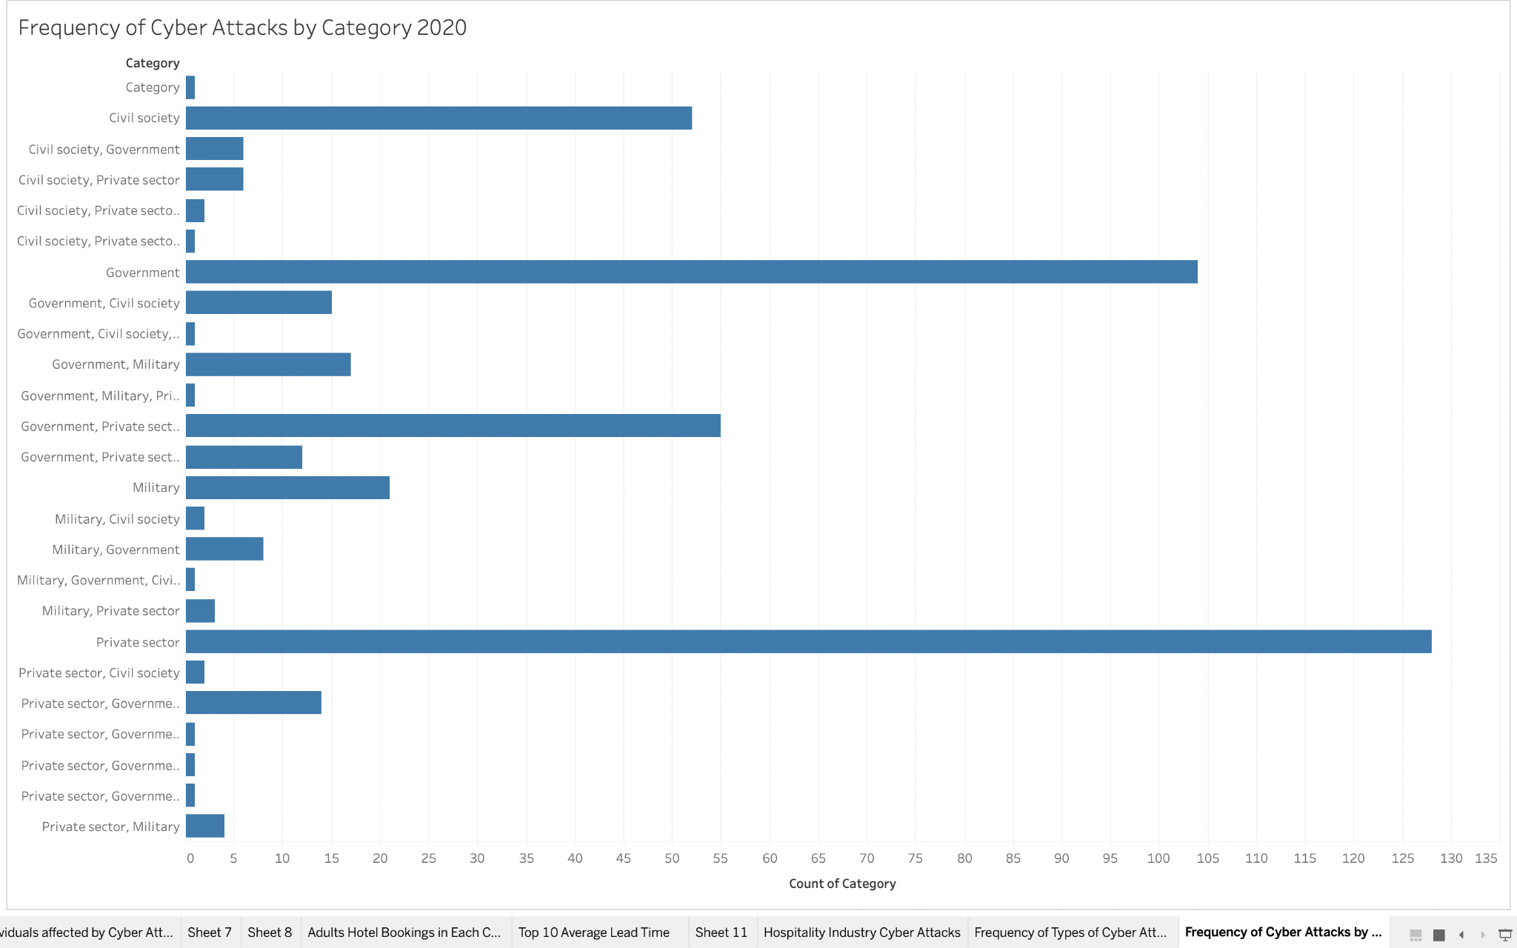

The visualizations above look closely at the recorded data breaches in 2020. The first looks at the frequency by type. This is important for us to analyze, as it can help us understand what types of data may be most at risk and focus our attention on protecting them. The second bar chart looks at the frequency of data breaches by category. In the hotel industry, our company falls into the Private Sector. As we can see in the chart, more cyber attacks occurred in the private sector than any other category in 2020. This shows our company that there is a serious need to protect our critical assets.

**Part 4: Group Roles and Signature**

Austin Habecker - worked on part 2 and 3 with Erika

Erika Banfield - Created and analyzed visualizations for part 2 and 3 with Austin

Shelby Chapa- Took short notes for group meeting and worked on Part 1.